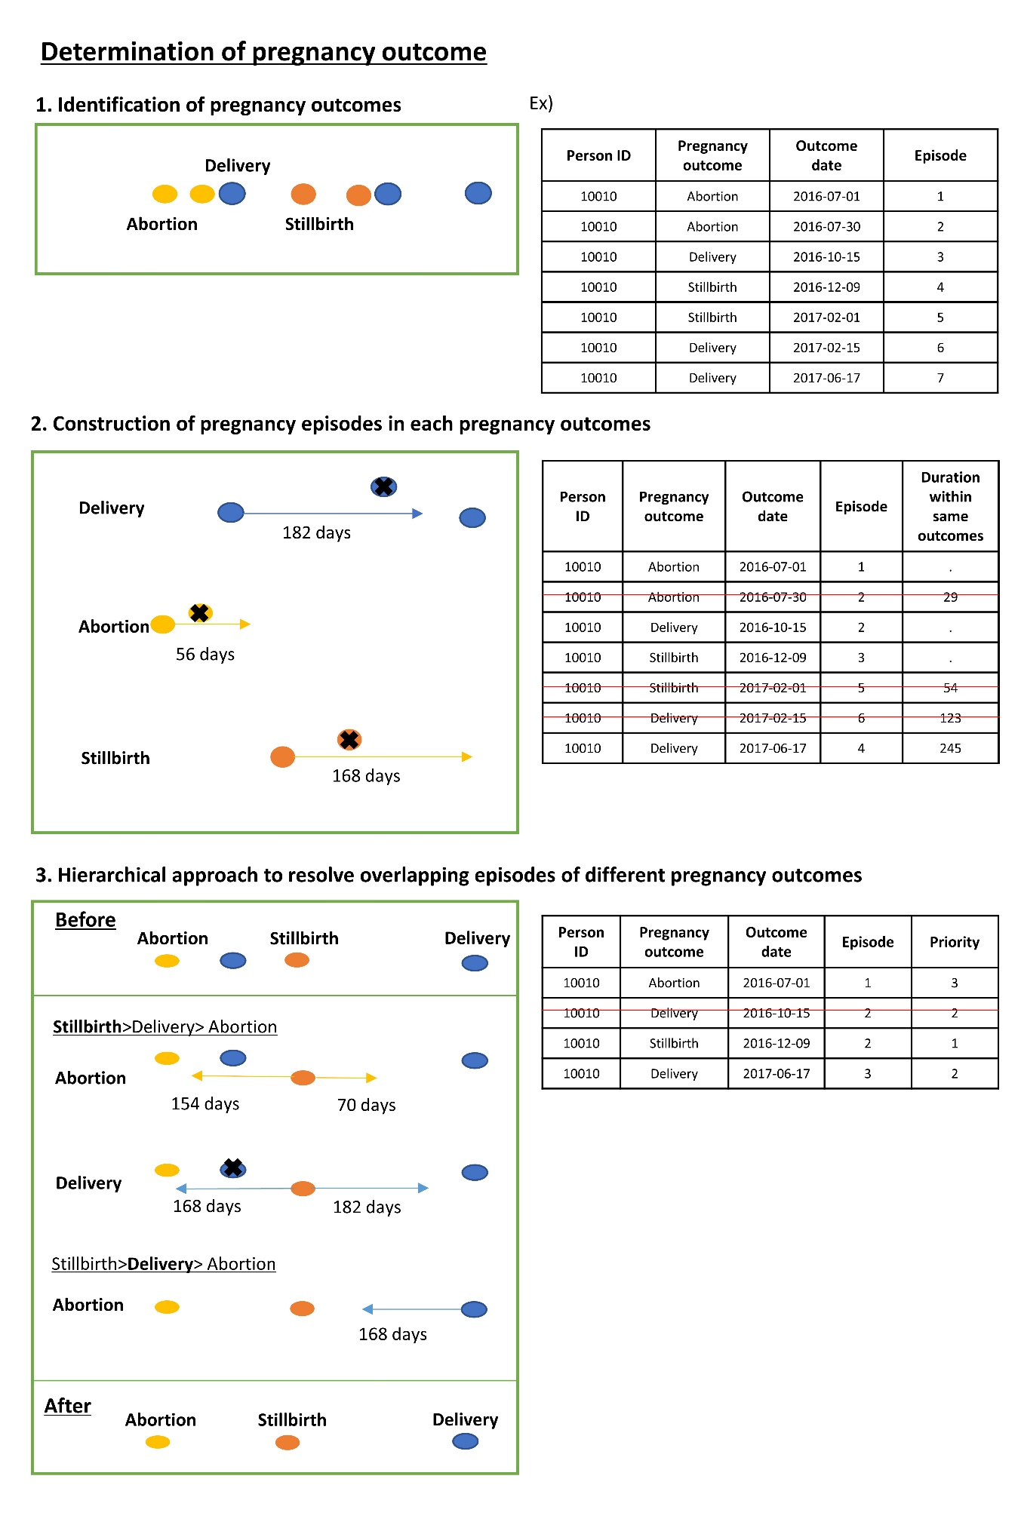 Supplementary Material 4 A sequential illustration of pregnancy episode determination

