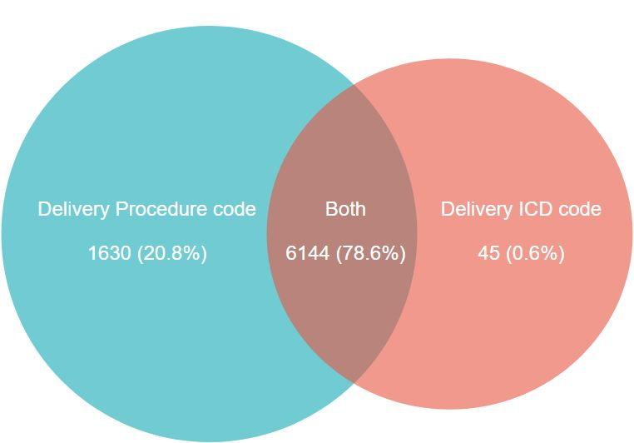
Supplementary Material 2 Distribution of procedure codes and diagnosis codes for delivery

