Supplementary Material 5. Funnel plots of the meta-analysis of studies examining the relationship between cancer type and alcohol consumption levels.

A. Esophageal cancer
Light | Light to moderate
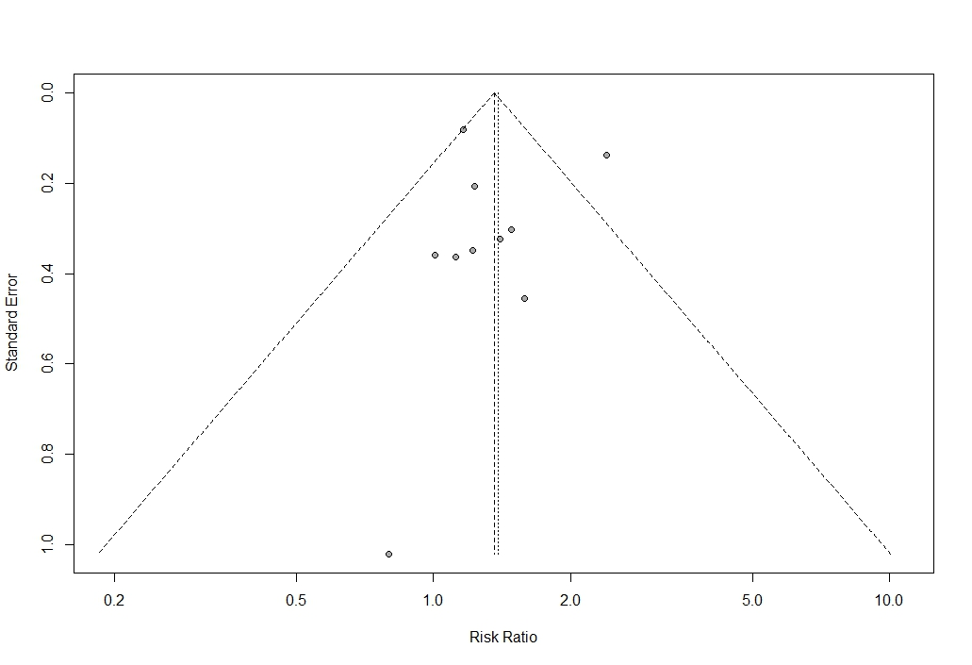 | 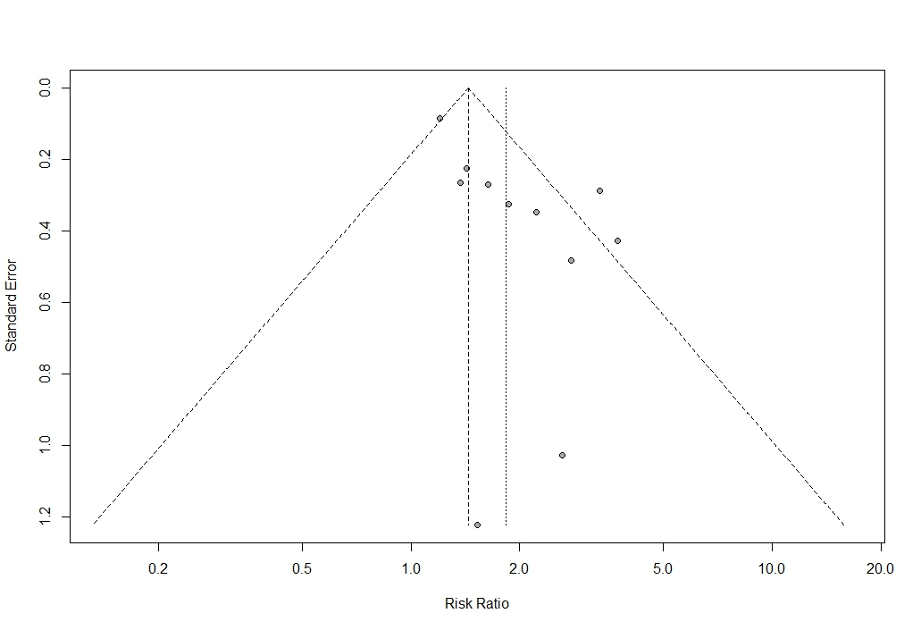
Egger test p-value = 0.95 | Egger test p-value = 0.01
Moderate to heavy | Heavy
- | 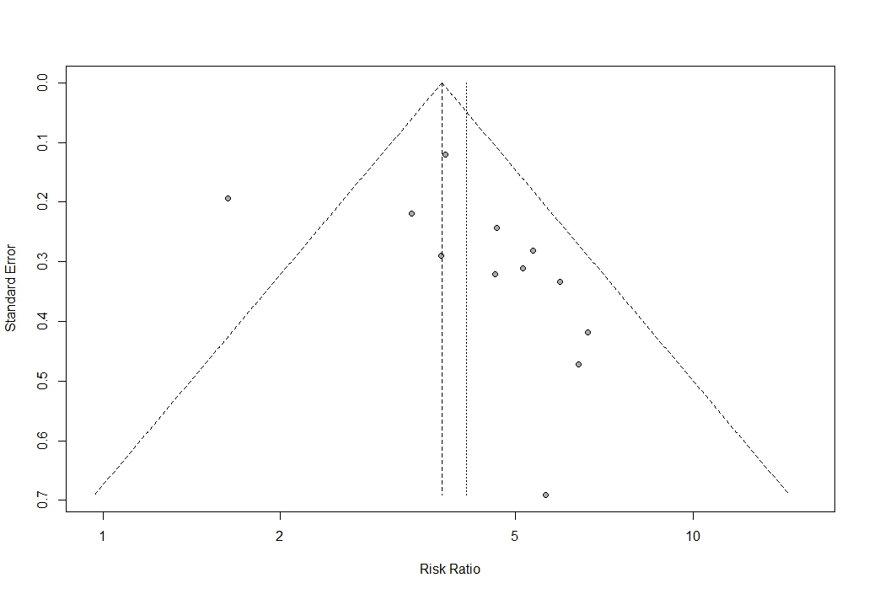
- | Egger test p-value = 0.14
The range of alcohol consumption levels was divided light (0.01–12.4 g/day), light to moderate (12.5–24.9 g/day), moderate to heavy (25.0–49.9 g/day), and heavy (50.0+ g/day).
B. Colorectal cancer
Light | Light to moderate
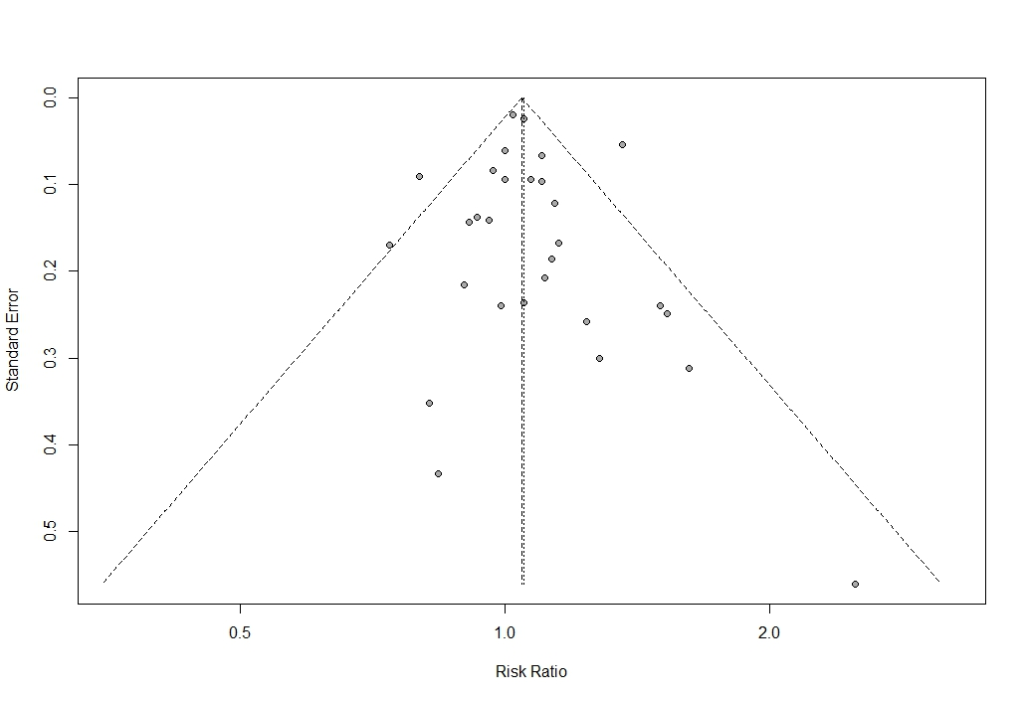 | 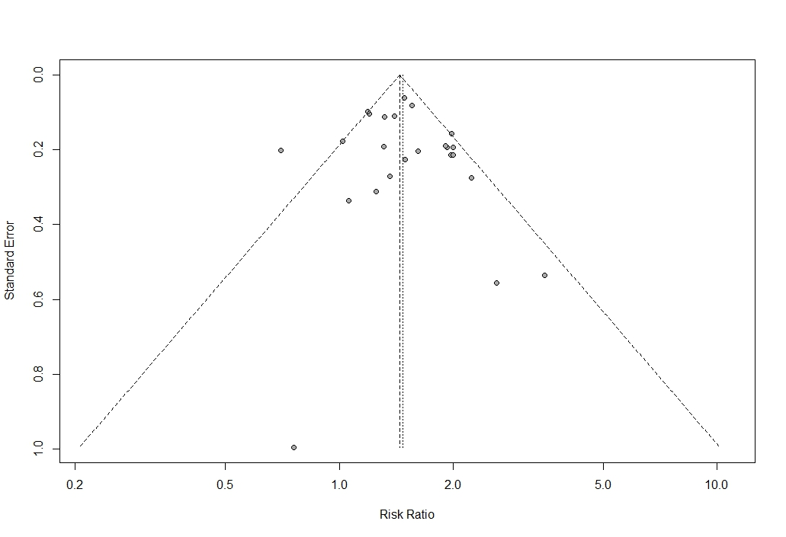
Egger test p-value = 0.57 | Egger test p-value = 0.75
Moderate to heavy | Heavy
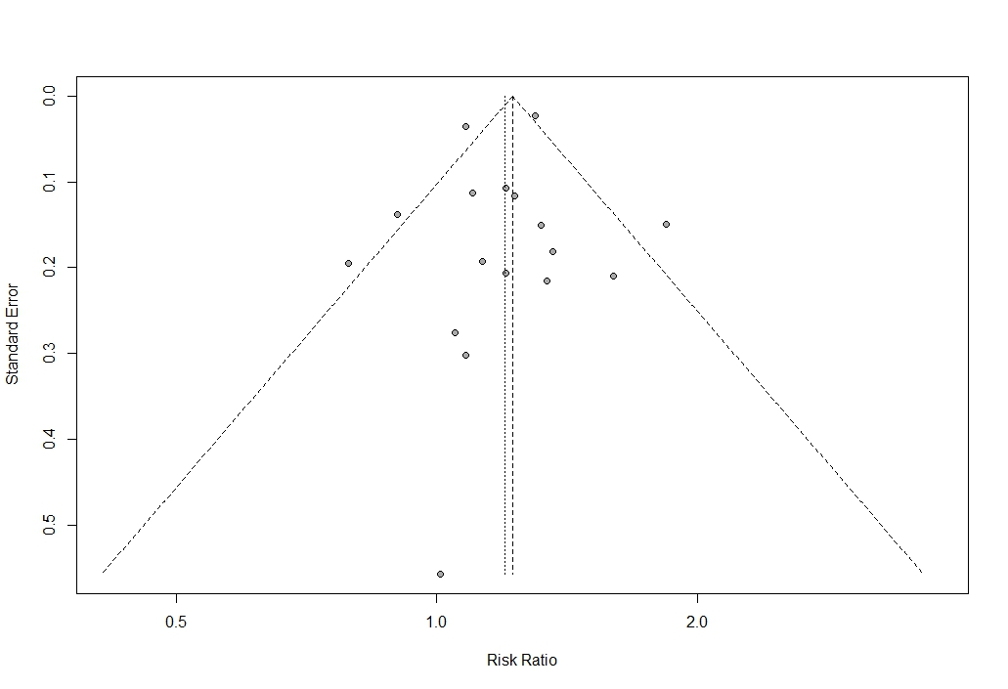
Egger test p-value = 0.59 | Egger test p-value = 0.89
The range of alcohol consumption levels was divided into light (0.01–12.4 g/day), light to moderate (12.5–24.9 g/day), moderate to heavy (25.0–49.9 g/day), and heavy (50.0+ g/day).

C. Lung cancer
Light | Light to moderate
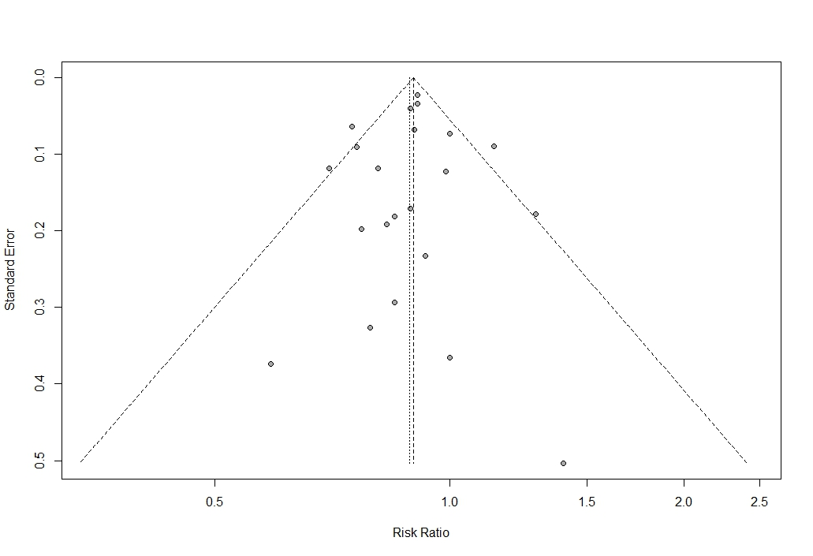 | 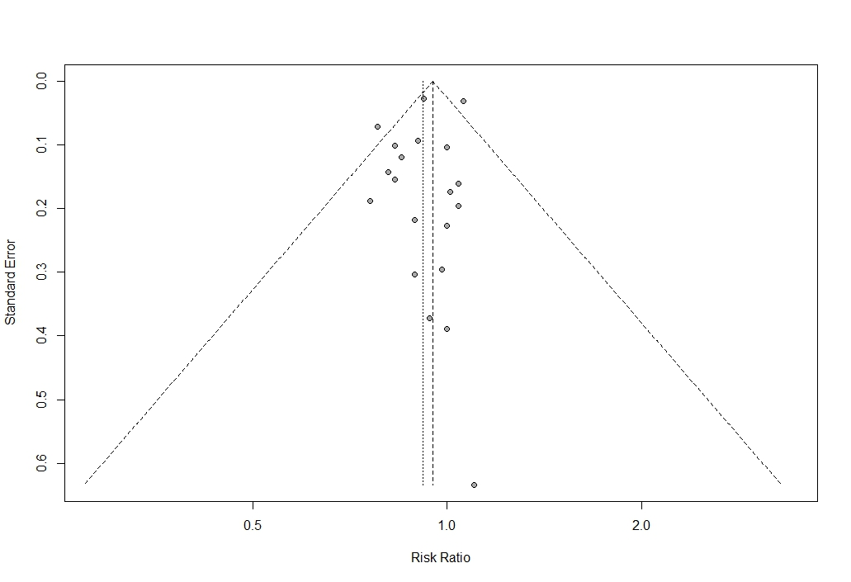
Egger test p-value = 0.66 | Egger test p-value = 0.28
Moderate to heavy | Heavy
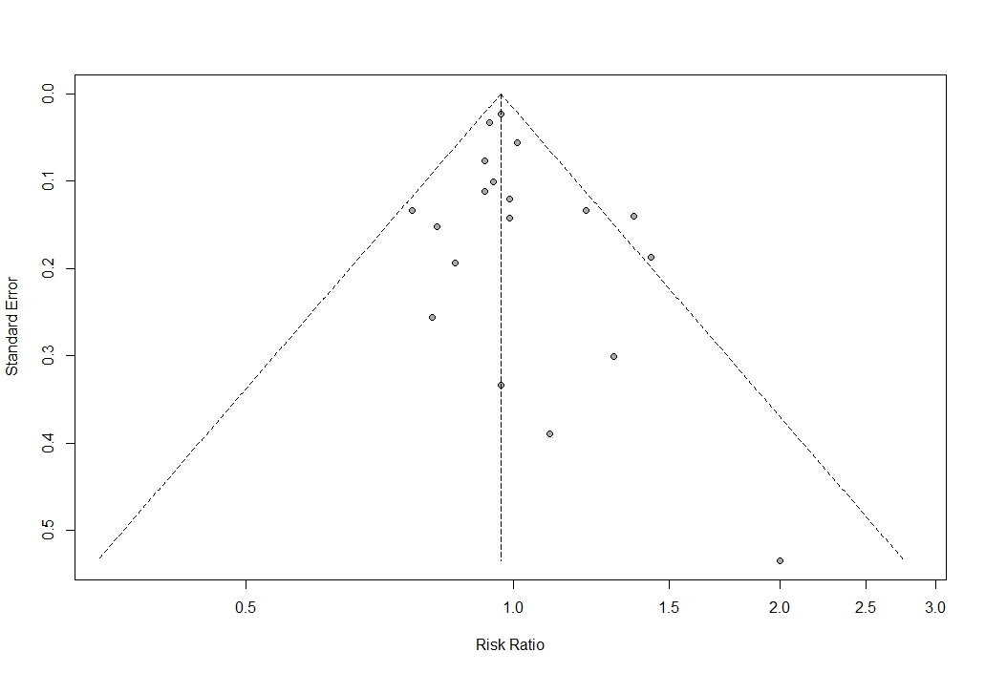 | 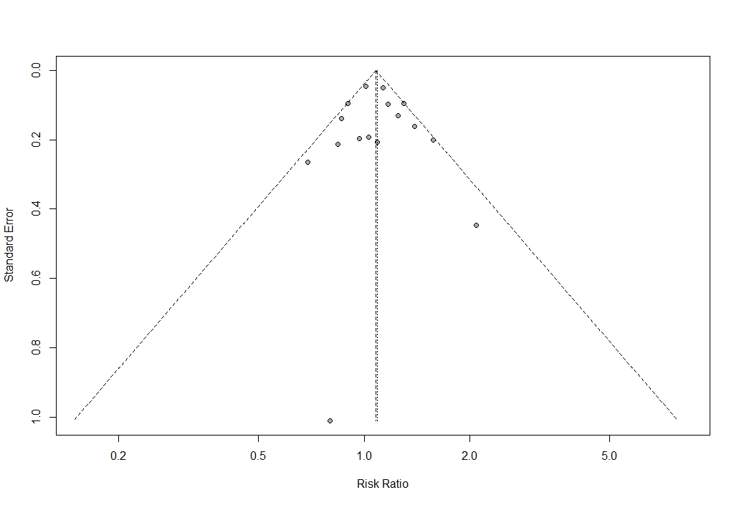
Egger test p-value = 0.27 | Egger test p-value = 0.78
The range of alcohol consumption levels was divided into light (0.01–12.4 g/day), light to moderate (12.5–24.9 g/day), moderate to heavy (25.0–49.9 g/day), and heavy (50.0+ g/day).

D. Prostate cancer
Light | Light to moderate
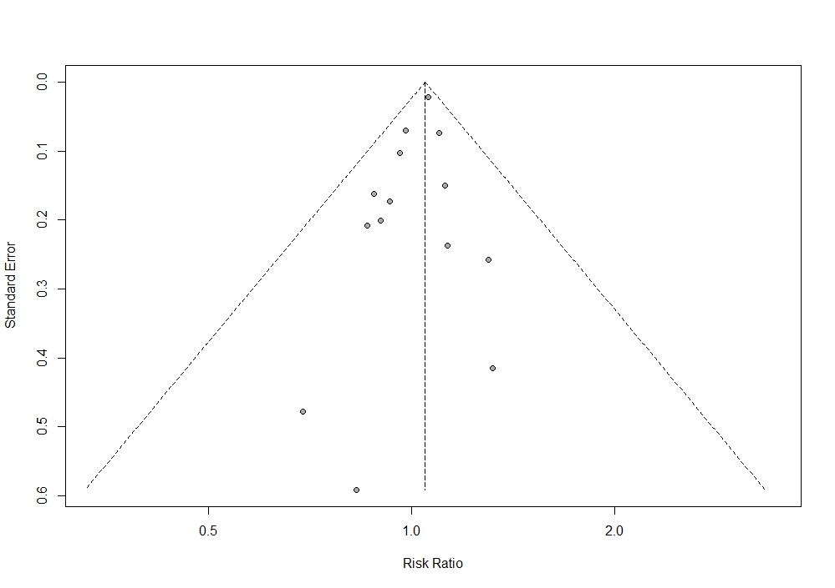 | 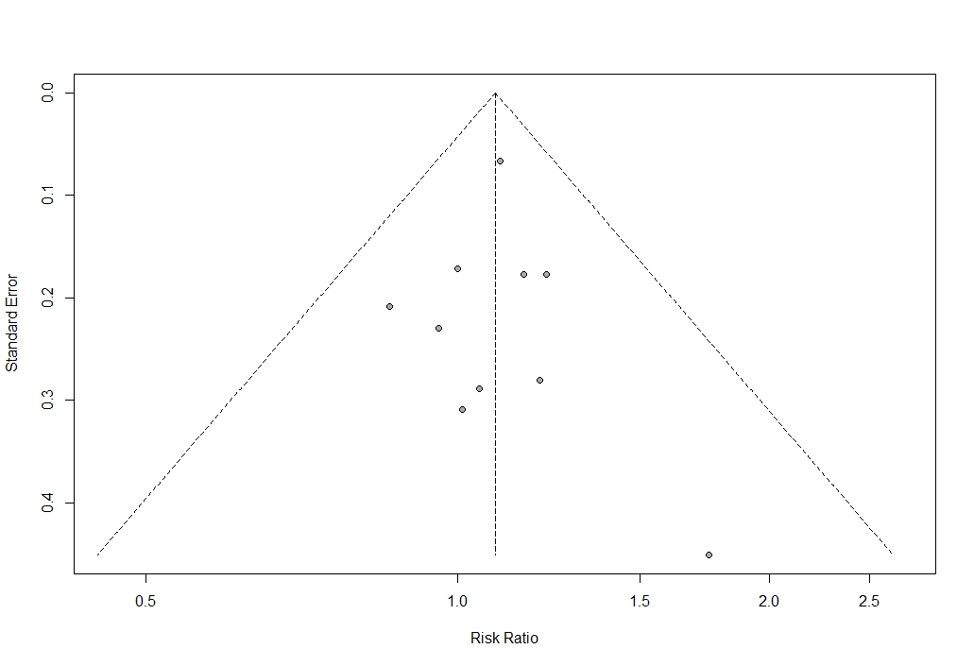
Egger test p-value = 0.16 | Egger test p-value = 0.96
Moderate to heavy | Heavy
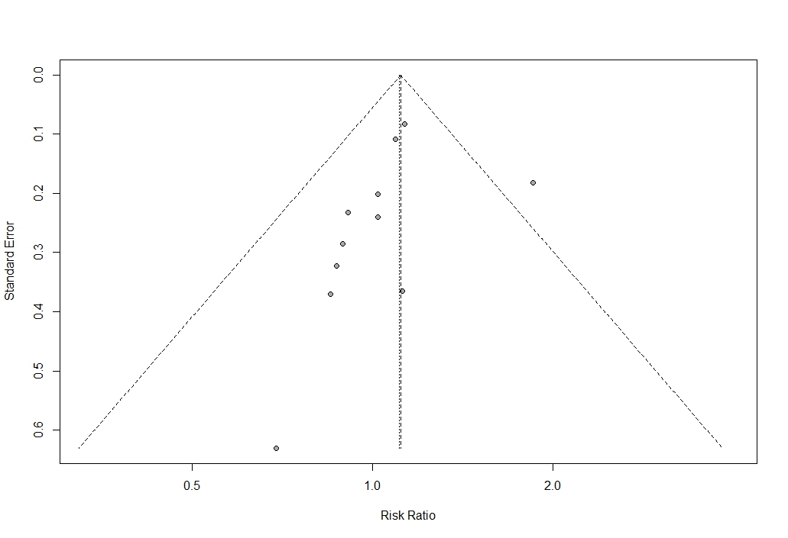 | 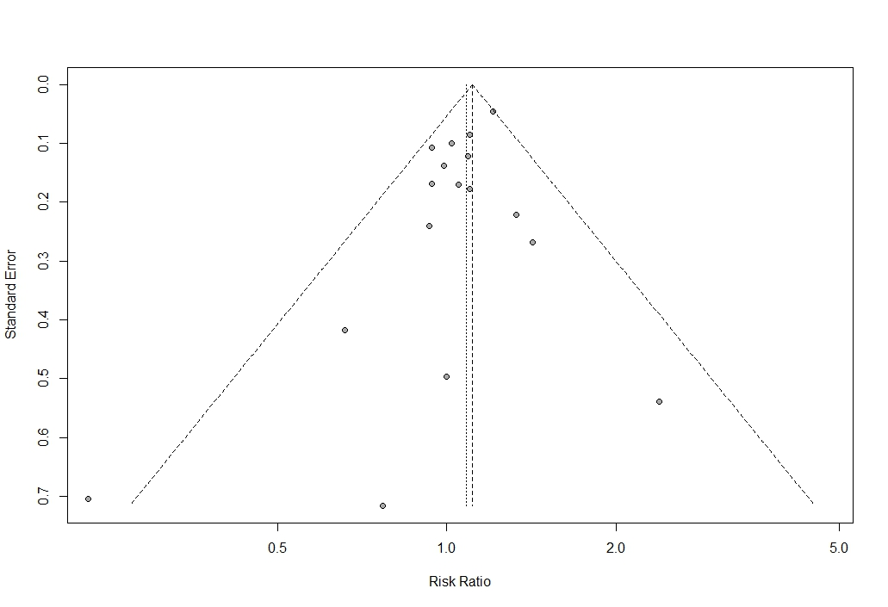
Egger test p-value = 0.32 | Egger test p-value = 0.08
The range of alcohol consumption levels was divided into light (0.01–12.4 g/day), light to moderate (12.5–24.9 g/day), moderate to heavy (25.0–49.9 g/day), and heavy (50.0+ g/day).

E. Breast cancer
Light | Light to moderate
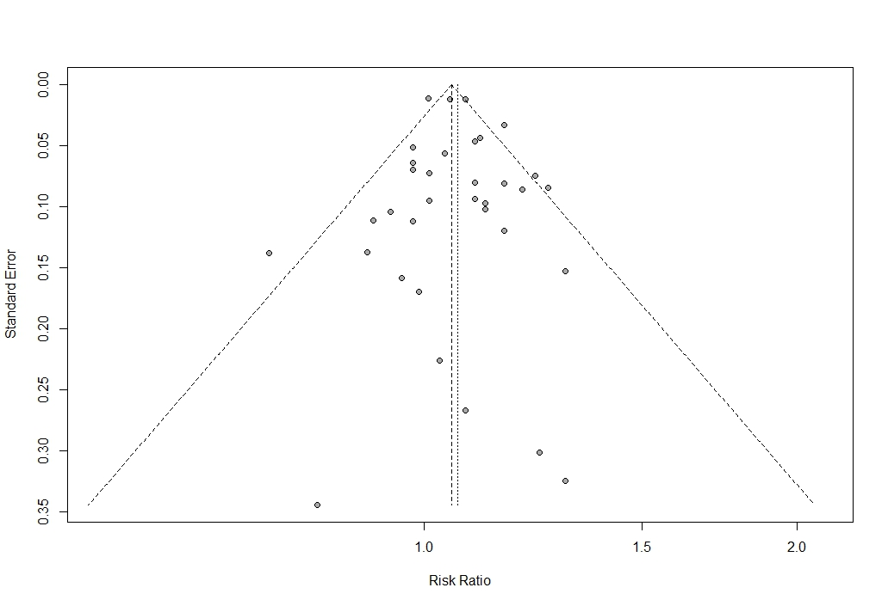 | 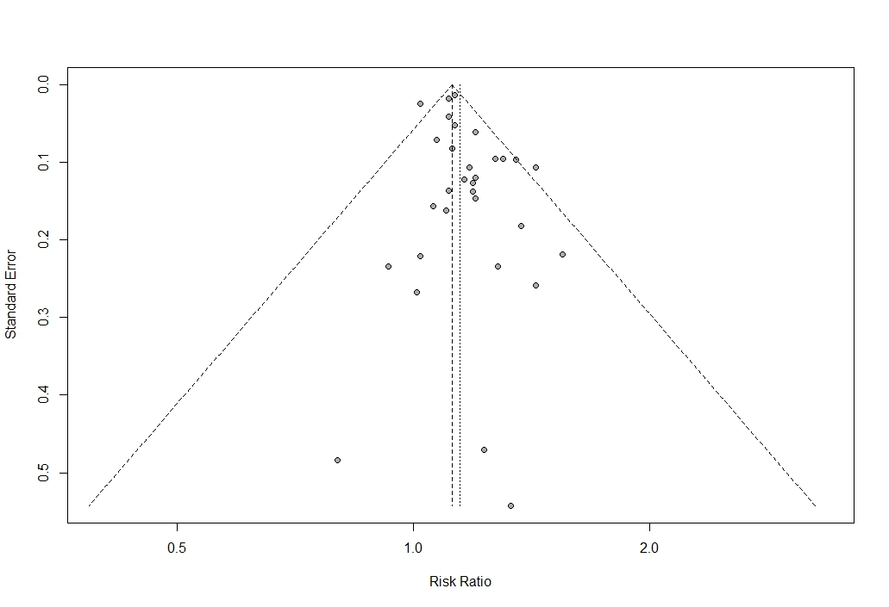
Egger test p-value = 0.53 | Egger test p-value = 0.04
Moderate to heavy | Heavy
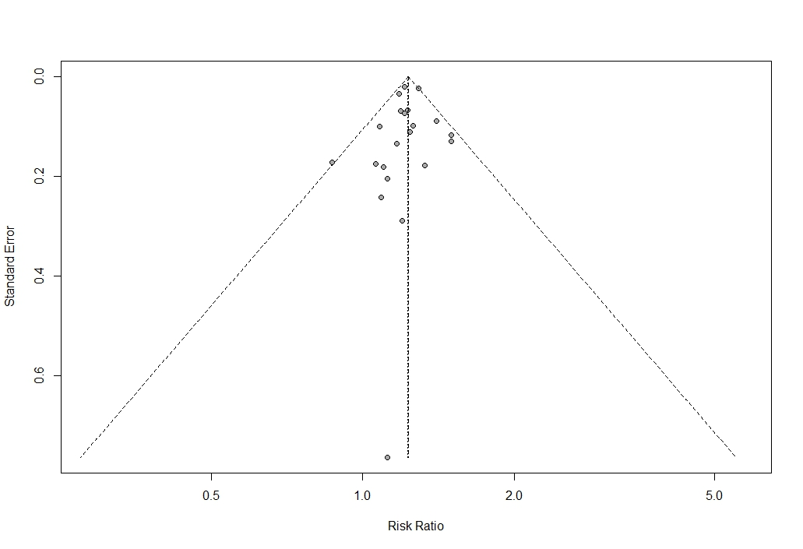 | 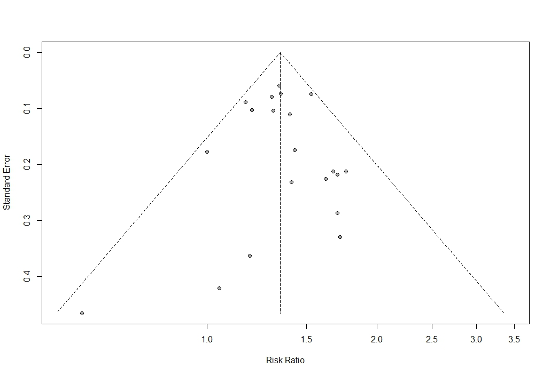
Egger test p-value = 0.56 | Egger test p-value = 0.83
The range of alcohol consumption levels was divided into light (0.01–12.4 g/day), light to moderate (12.5–24.9 g/day), moderate to heavy (25.0–49.9 g/day), and heavy (50.0+ g/day).

