Supplementary Material 8. Estimates of adherence level and percentage of patients stratified by sex according to the predefined six methodologic measurements
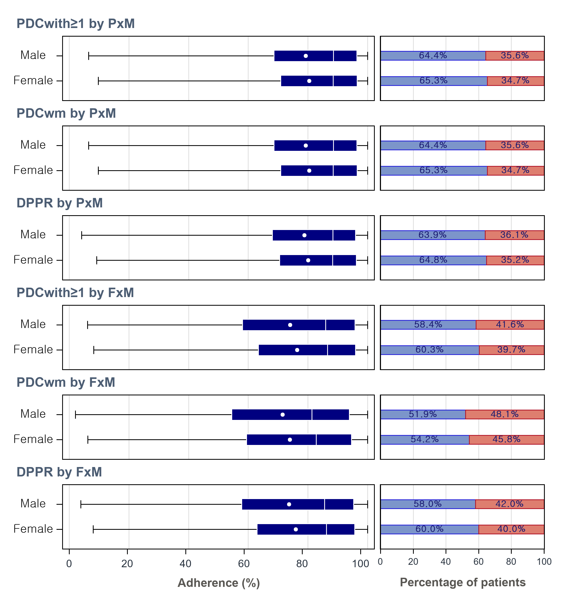
Abbreviation: DPPR, daily polypharmacy possession ratio; FxM, fixed period-based methodology; PDC_{with≥1}, proportion of days covered with at least one drug; PDC_{wm}, duration weighted mean PDC; PxM, prescription-based methodology.

