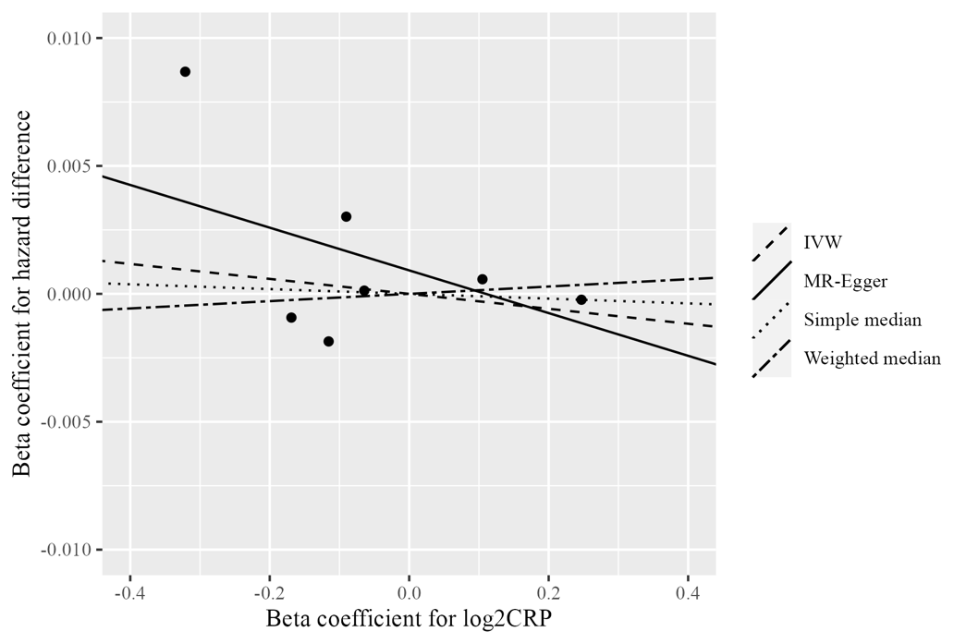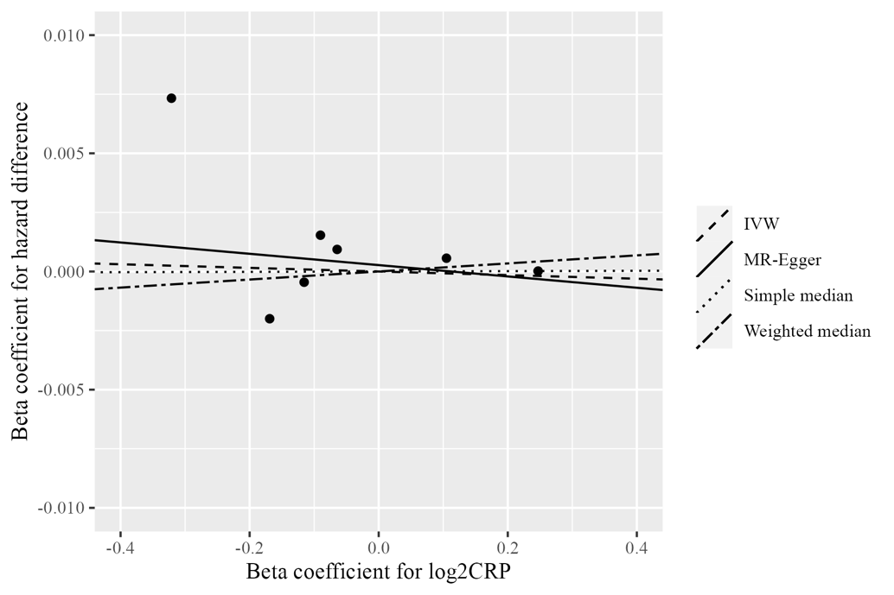
A
B
Supplementary Material 6. Scatter plot of SNP-specific associations with overall (A) and CRC-specific (B) mortality against coefficients of SNP-CRP associations. The slope of the regression line provides an estimate of the association between genetically predicted serum CRP and survival.

