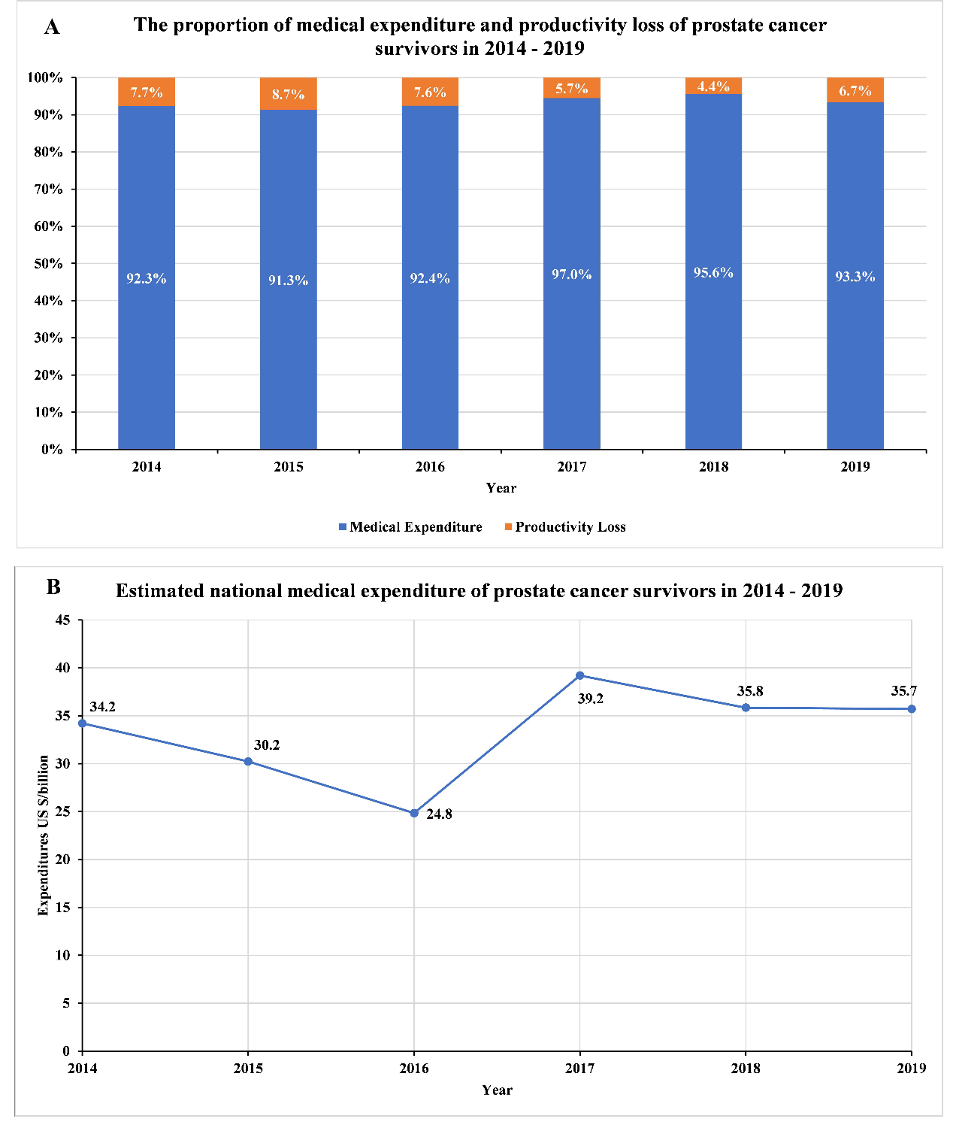
Supplementary Fig 4. The sum of healthcare expenditures for prostate cancer survivors in the United States, 2014 – 2019. (A) the proportion of medical expenditure and productivity loss (B) estimated national medical expenditure.

