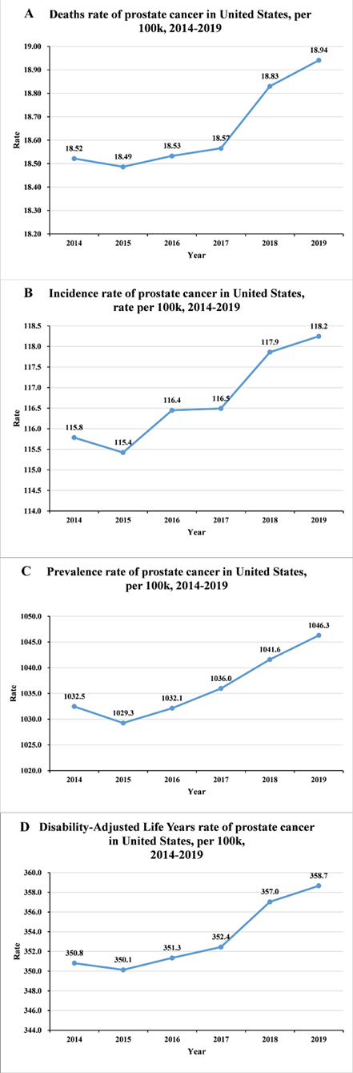
Supplementary Fig 3. The rate of age-standardized rates for prostate cancer cases in the United States from 2014-2019. (A) rates of deaths, (B) rates of incidence, (C) rates of prevalence and (D) rates of DALYs.

