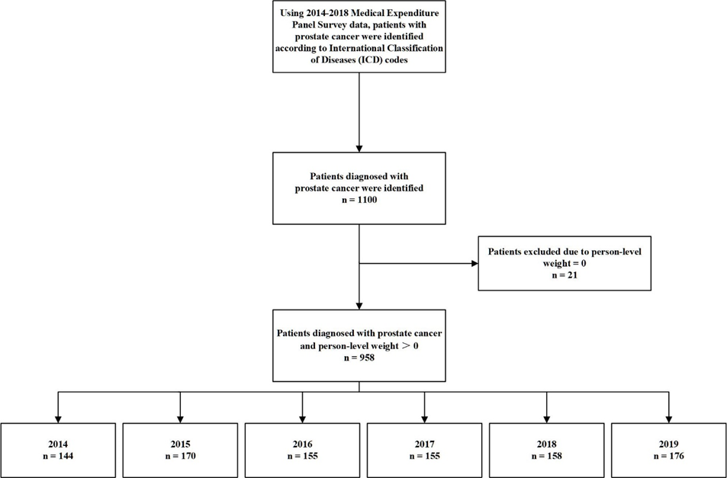
Note: Here in ICD code included the ICD-9 codes (code=185, before 2015) and ICD-10 codes (code=C61, after 2016) used to identify the patients.
Supplementary Fig 1. Flow diagram of included prostate cancer patients.

