Supplementary Material 3. Trend in the cancer treatment rate (age-standardized rate) among patients with newly diagnosed stage IV cancers near the end of life between 2012 and 2017
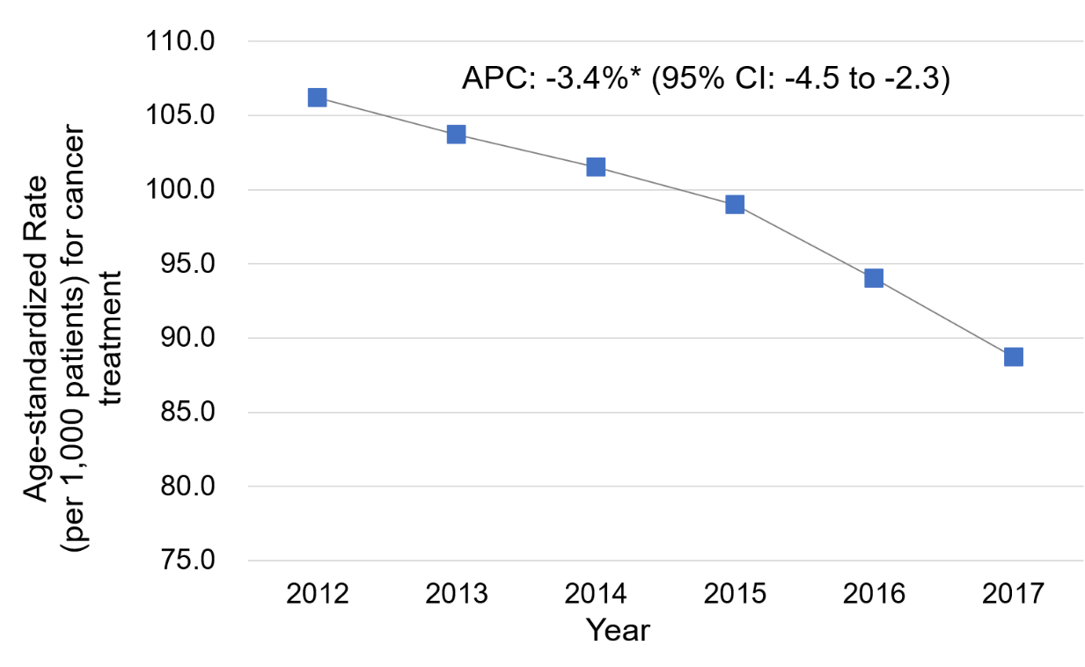
NOTE: The following cancer types were included: gastric cancer, colorectal cancer, liver cancer, pancreatic cancer, and lung cancer. Age-standardized rate was computed by standardizing age distribution of the Korean population in 2012
Acronym: APC, annual percent change
*p<0.05

