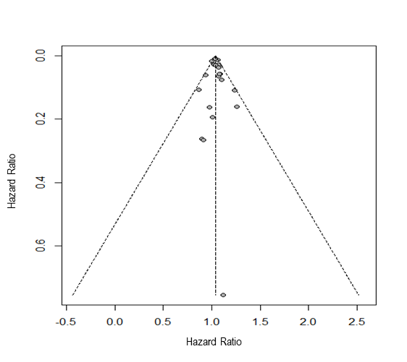
Supplementary Material 2. Funnel plot for the GHG emission from diet and chronic disease incidence and mortality.

