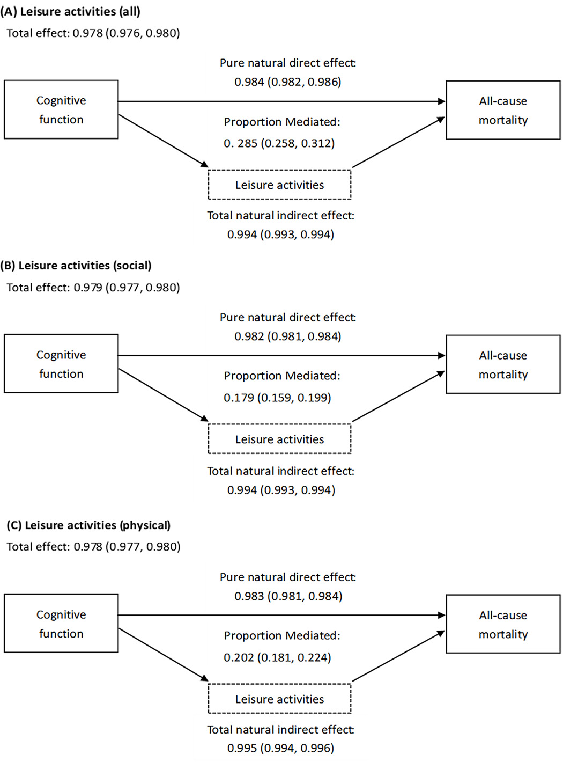
Supplementary Material 6. Sensitivity analyses of causal mediation of leisure activities on cognitive function and all-cause mortality by including participants who had missing values on key variables (adjusted for age, sex, residence, smoking status, drinking status, tea drinking, regular physical activity, lifestyle, and eight kinds of self-reported disease) (n = 42,942).

