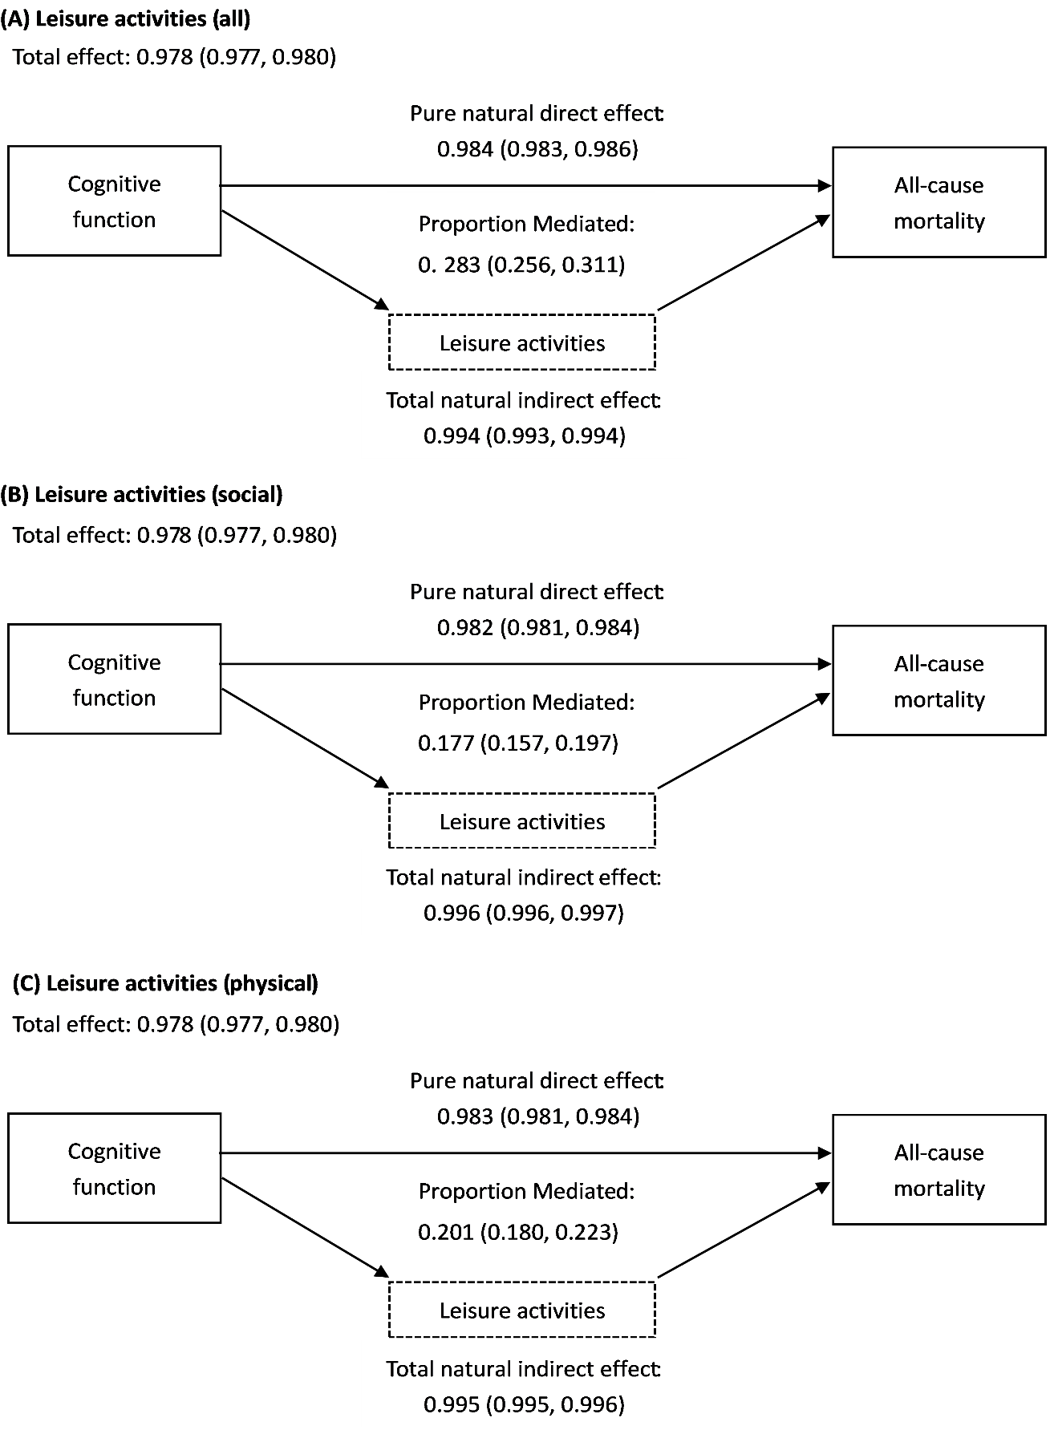
Supplementary Material 5. Sensitivity analyses of causal mediation of leisure activities on cognitive function and all-cause mortality by applying interaction effects (adjusted for age, sex, residence, smoking status, drinking status, tea drinking, regular physical activity, lifestyle, and eight kinds of self-reported disease).

