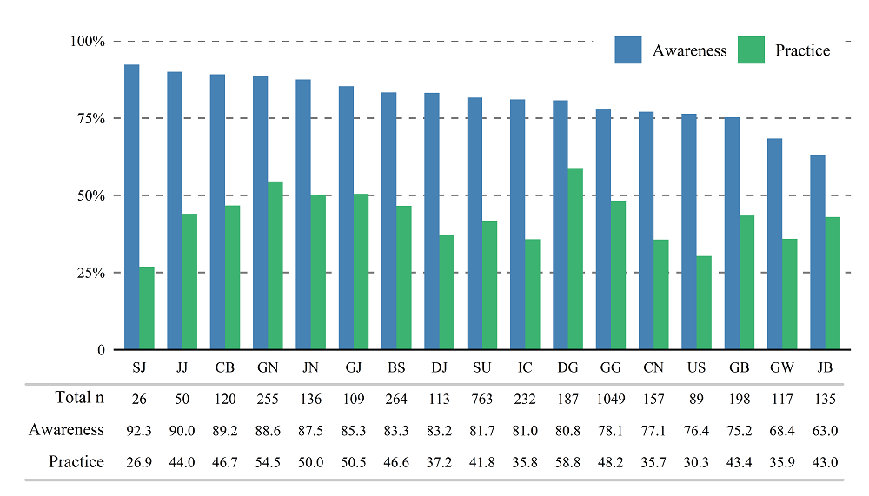
Supplementary Material 2. The awareness and practice of cancer prevention by region in 2021.
SU, Seoul; BS, Busan; DG, Daegu; IC, Incheon; GJ, Gwangju; DJ, Daejeon; US, Ulsan; SJ, Sejong; GG, Gyeonggi; GW, Gangwon; CB, Chungbuk; CN, Chungnam; JB, Jeonbuk; JN, Jeonnam; GB, Gyeongbuk; GN, Gyeongnam; JJ, Jeju.

