Supplementary Material 1. National Cancer Prevention Guidelines

- Don't smoke, and avoid secondhand smoke
- Eat plenty of fruits and vegetables and eat a balanced meal with a colorful diet
- Do not eat salty food or burnt food
- Avoid drinking even as little as one or two glasses of alcohol a day
- Walk or exercise to the point of sweating at least 30 minutes a day at least 5 days a week
- Maintain a healthy weight for your body
- Receive hepatitis B and cervical cancer vaccines according to the vaccination guidelines
- Practice safe sex to avoid contracting sexually transmitted infectious diseases
- Follow safety and health rules at work to avoid exposure to carcinogenic substances
- Get appropriate cancer screenings according to screening guidelines to detect cancer at early stages

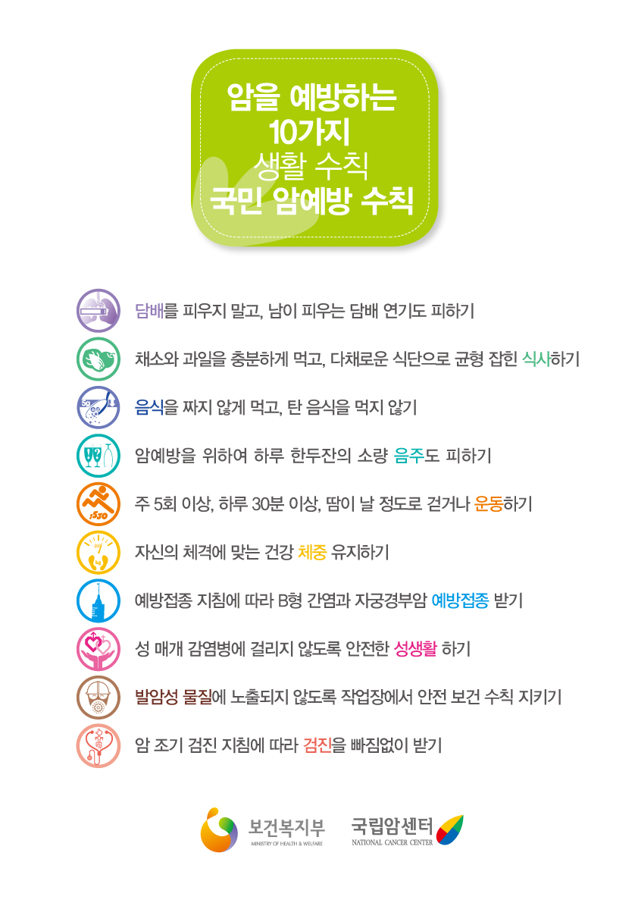
Source: www.cancer.go.kr

