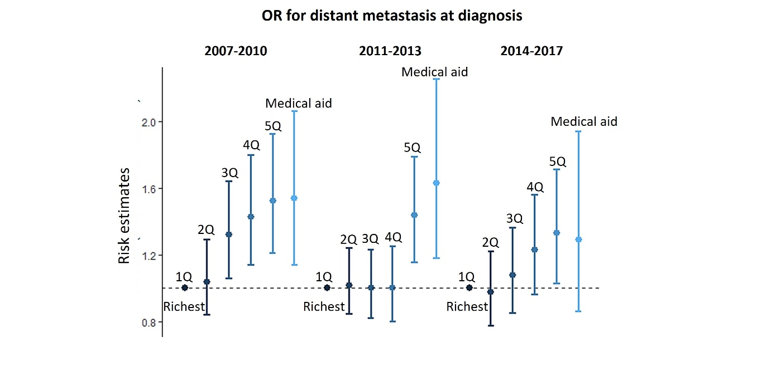
Supplementary Material 2. Adjusted odds ratios for advanced stage at presentation across relative level of income by year of cervical cancer diagnosis, National Cancer Registry of Korea linked with the National Health Information Database of National Health Insurance database in 2007-2017 (n=31,391). OR, odds ratio; 1Q, 1st quintile (richest); 2Q, 2nd quintile; 3Q, 3rd quintile; 4Q, 4th quintile; 5Q, 5th quintile. Estimates are adjusted for age, body mass index, employment, disability, and Seoul metropolitan area residence.

