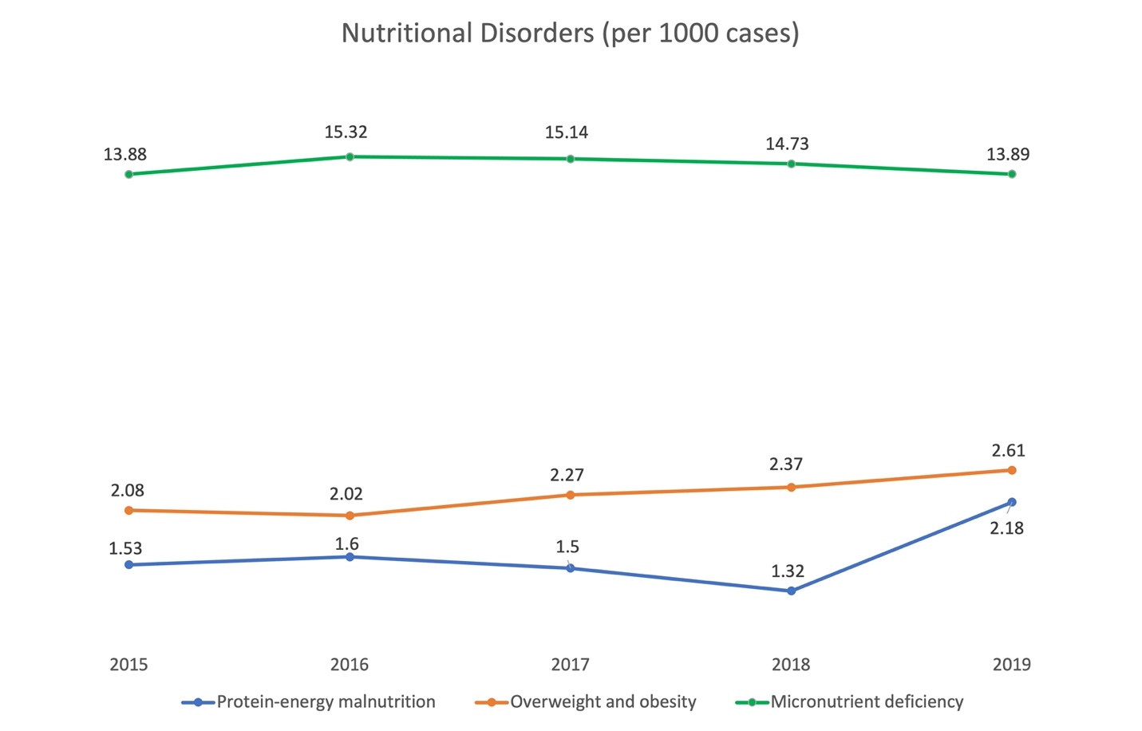

Supplementary Material 2. Prevalence of malnutrition with coded diagnoses of nutritional disorders in hospitalized children by year (per 1000 cases)

