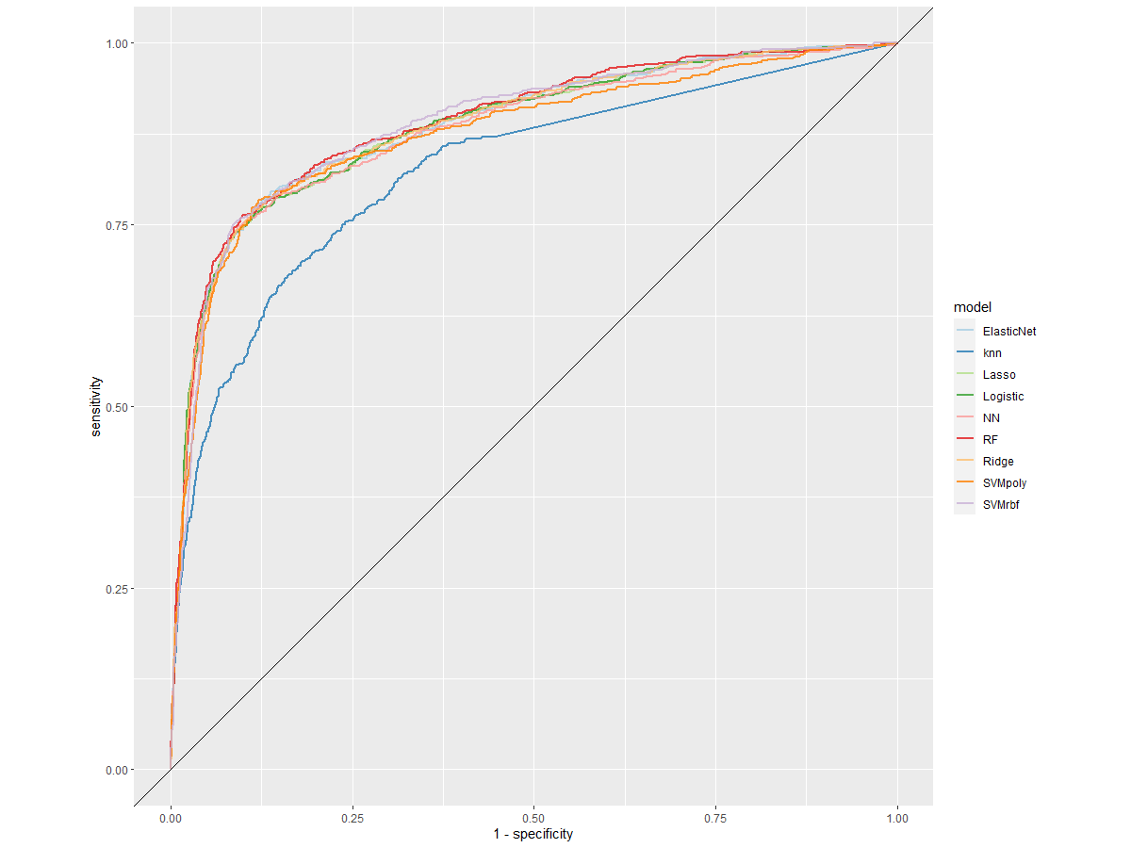
Supplementary Material 9. Receiver operating characteristic (ROC) curve of cross-validated classification performance of each model in sensitivity analyses 2 and 3.

