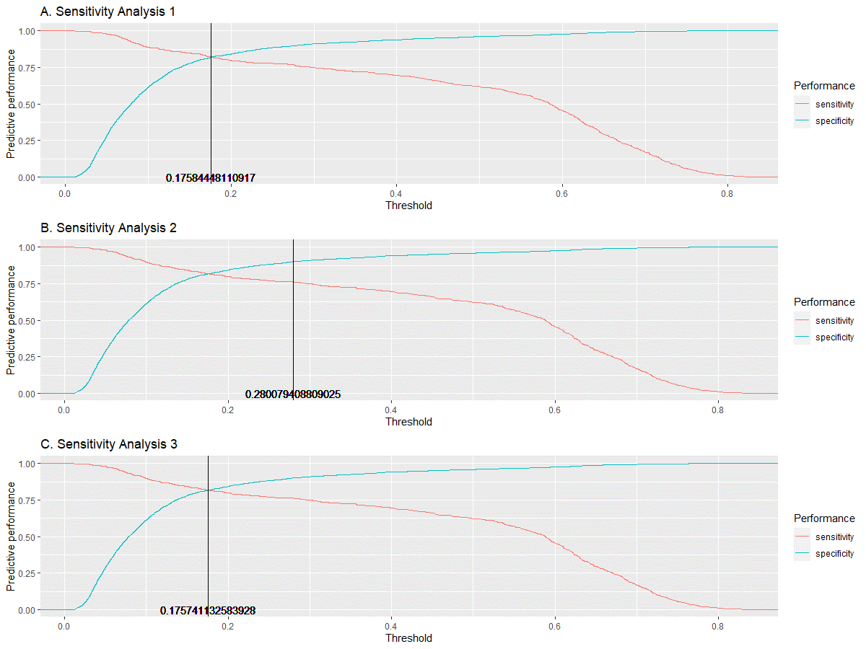
Supplementary Material 6. Predictive performance of the best-performing machine learning algorithm (random forest) across different probability threshold values, and the optimal value of the probability threshold for classification in the sensitivity analyses.

