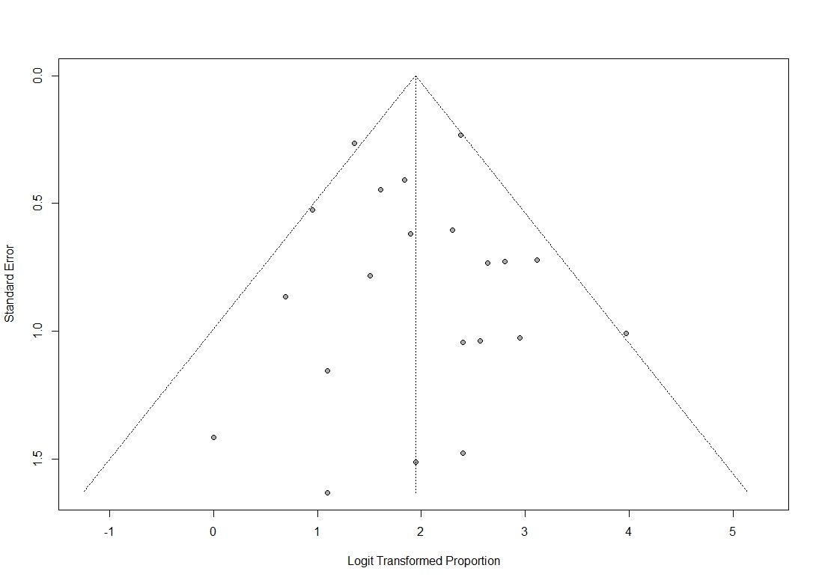
Supplementary Material 3. Funnel plot for the assessment of publication bias following a meta-analysis of proportion.

