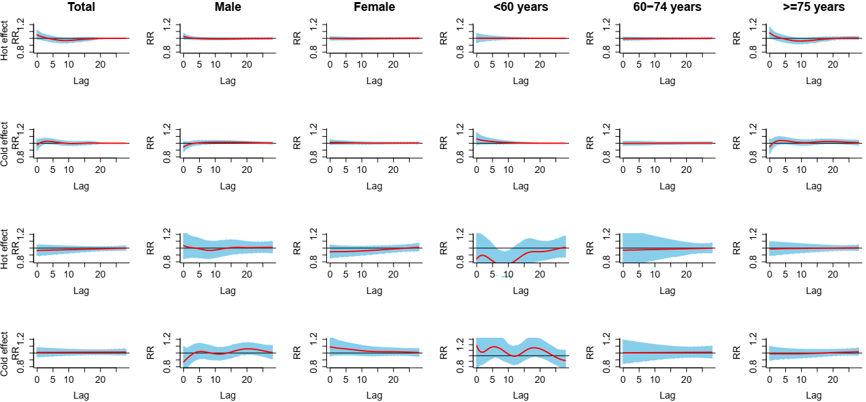

**Supple­mentary Material 1:** The estimated hot effects (99th percentile of temperature (41.2°C) relative to 75th percentile of temperature (36.6°C)) and cold effects (1st percentile of temperature (9.3°C) relative to 25th percentile of temperature (18.1°C)) of mean temperature on cardiovascular (row 1 and 2) and respiratory (row 3 and 4) mortality along the lag days.

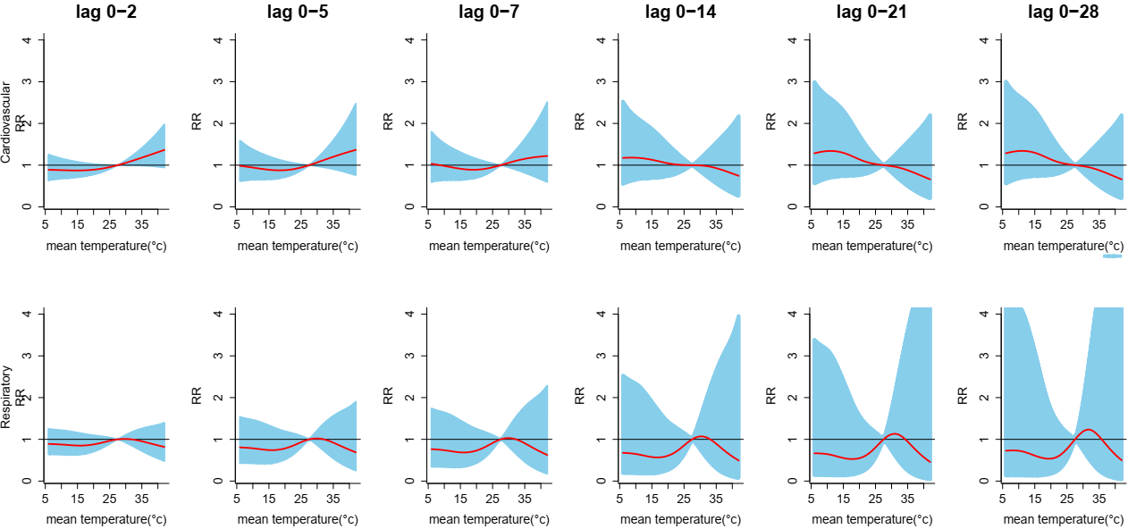

**Supple­mentary Material 2:** The overall cumulative temperature-mortality associations with 95% Cis in different lag structures. The reference value was median temperature (27.3°C).