Supplement 3. Household SHS exposure by period and school admission cohort stratified by grade among Korean boys and girls.
Boys | Girls
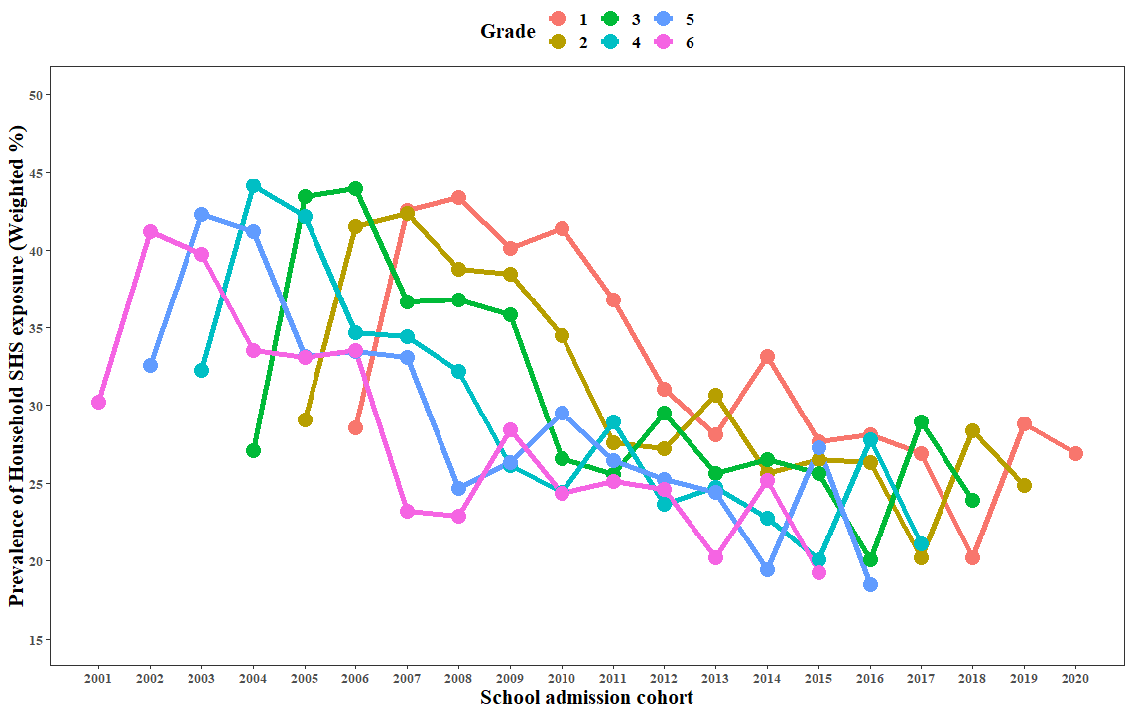  - School admission cohort * Grade | 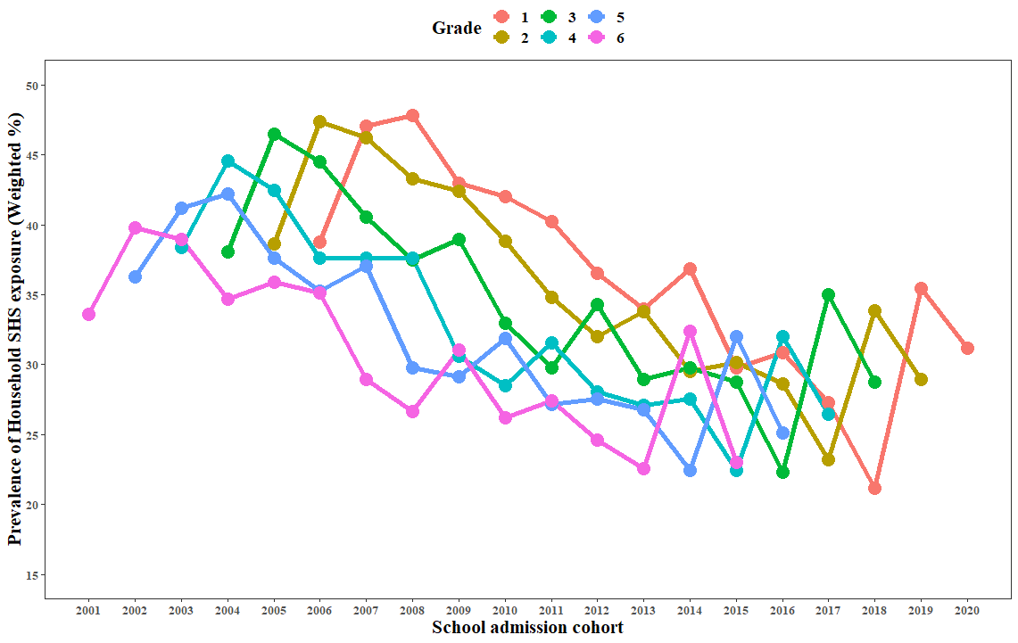  - School admission cohort * Grade
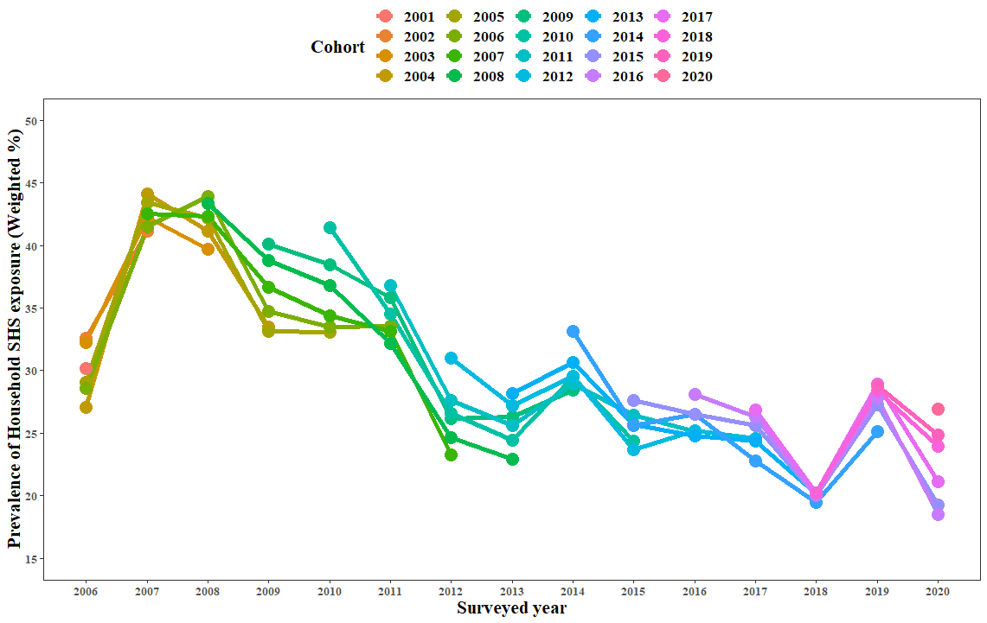  - Period * School admission cohort | 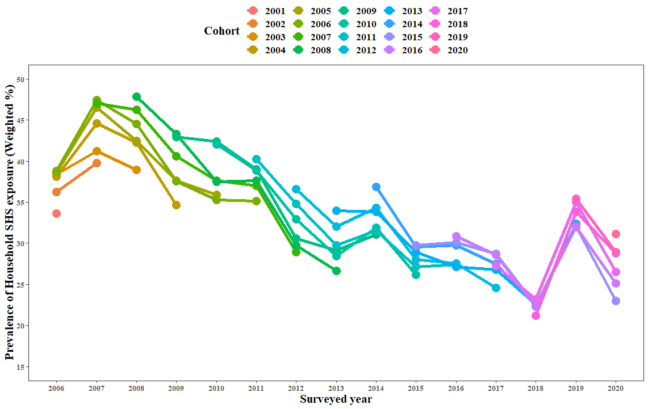  - Period * School admission cohort
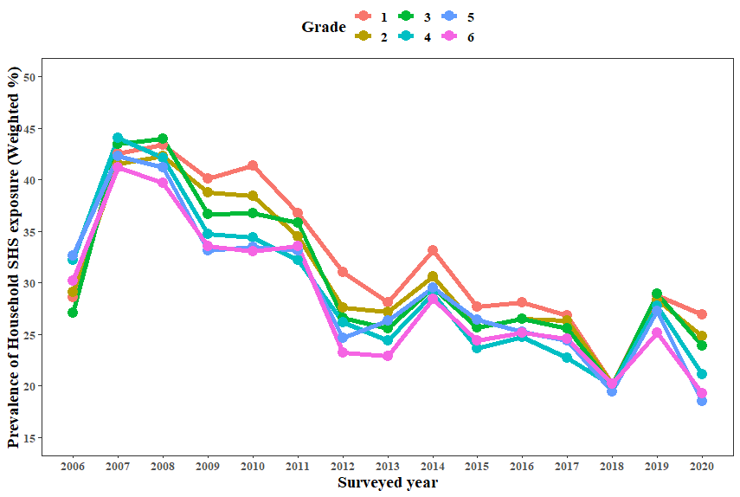  - Period * Grade | 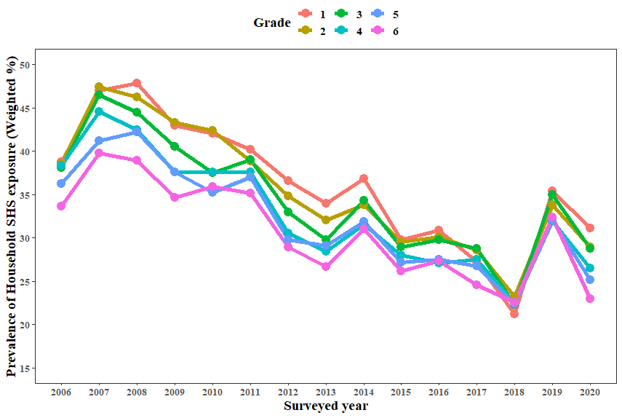  - Period * Grade

