Association between cumulative average of dietary total antioxidant capacity and intake of antioxidants with metabolic syndrome risk in Korean adults aged 40 years and older: a prospective cohort study (KoGES_CAVAS)

Supplemental Material 1.1. Nonlinear dose-response association of dTAC and antioxidants with incident MetS in men: a restricted cubic spline analysis with three knots (located at the 25th, 50th, and 75th percentiles)
Supplemental Material 1.2. Nonlinear dose-response association of dTAC and antioxidant classes with incident MetS in women: a restricted cubic spline analysis with three knots (located at the 25th, 50th, and 75th percentiles)
Supplemental Material 2.1. Nonlinear dose-response association of total flavonoids and flavonoid subclasses with incident MetS in men: a restricted cubic spline analysis with three knots (located at the 25th, 50th, and 75th percentiles)
Supplemental Material 2.2. Nonlinear dose-response association of total flavonoids and flavonoid subclasses with incident MetS in women: a restricted cubic spline analysis with three knots (located at the 25th, 50th, and 75th percentiles)
Supplemental Material 3. Baseline characteristics of the study participants (n=11,379)
Supplemental Material 4. Incidence rate ratios (IRRs) and 95% confidence intervals (CIs) of MetS by the quartiles of dTAC and antioxidant classes after censoring CVD and cancer (n=11,379)
Supplemental Material 5. Incidence rate ratios (IRRs) and 95% confidence intervals (CIs) of MetS by quartiles of dTAC and antioxidant classes among only non-users of antioxidant component supplement (n=8,786)
Supplemental Material 6. Incidence rate ratios (IRRs) and 95% confidence intervals (CIs) of MetS by quartiles of dTAC and antioxidant classes of their major food sources (n=11,379)
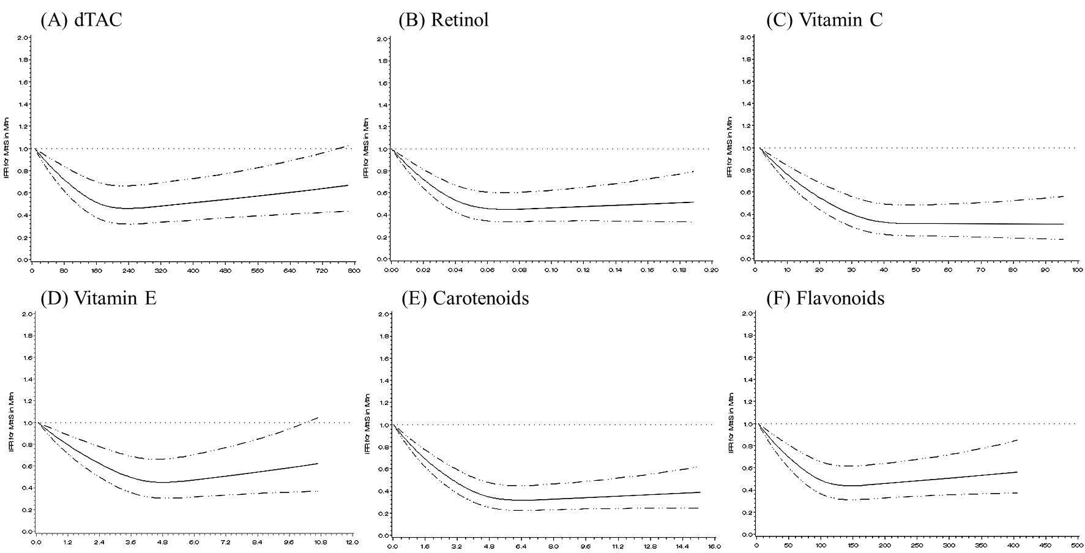
Supplemental Material 1.1. Nonlinear dose-response association of dTAC and antioxidant classes with incident MetS in men: a restricted cubic spline analysis with three knots (located at the 25th, 50th, and 75th percentiles)
MetS, metabolic syndrome; dTAC, dietary total antioxidant capacity.
Multivariable model was adjusted for age (years), higher education level (≥12 years of schooling), regular exercise (≥3 times/wk and ≥30 min/session), smoking status (current/past/never-smokers for men and current/non-smokers for women), drinking status (yes or no), body mass index (kg/m²), and dietary factors (total energy intake (kcal/day), glycemic index (GI), calcium (mg/day), fiber (g/day), magnesium (mg/day), and sodium (mg/day)) in men and women.
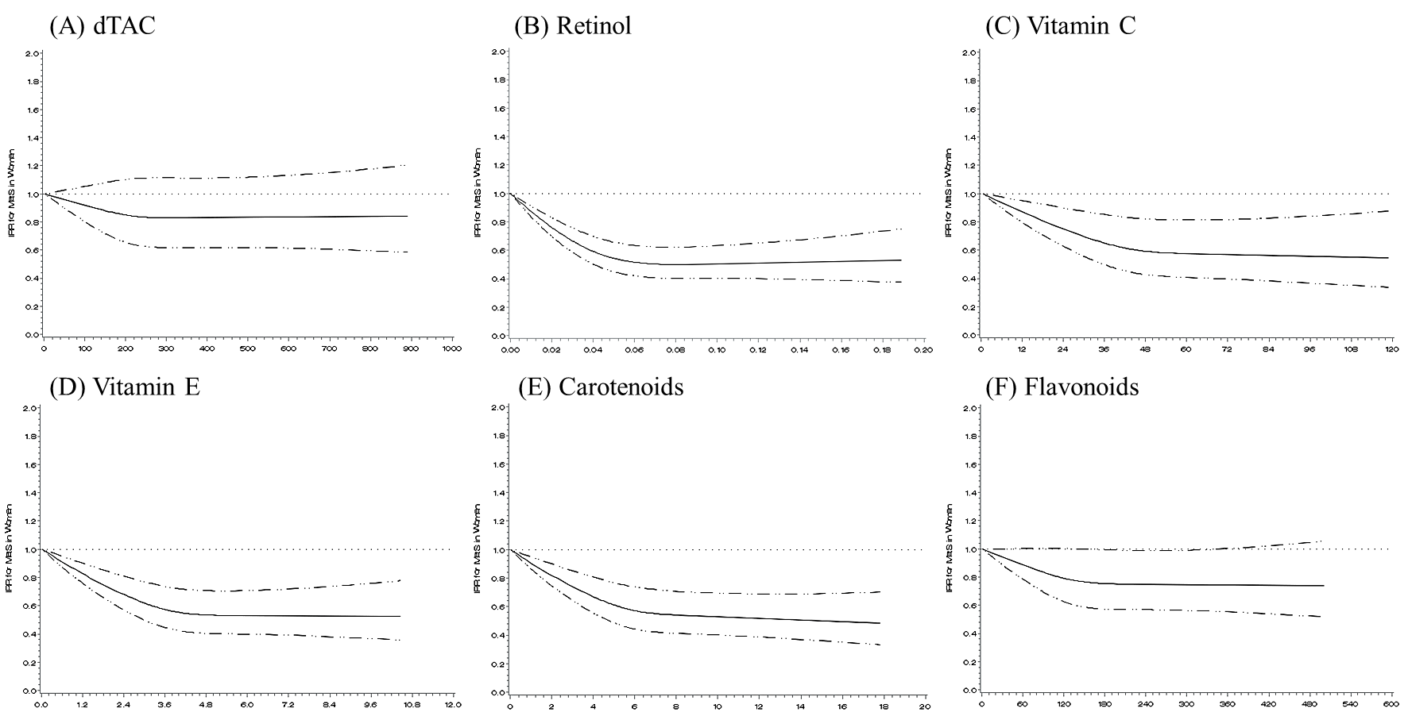
Supplemental Material 1.2. Nonlinear dose-response association of dTAC and antioxidants with incident MetS in women: a restricted cubic spline analysis with three knots (located at the 25th, 50th, and 75th percentiles)
MetS, metabolic syndrome; dTAC, dietary total antioxidant capacity.
Multivariable model was adjusted for age (years), higher education level (≥12 years of schooling), regular exercise (≥3 times/wk and ≥30 min/session), smoking status (current/past/never-smokers for men and current/non-smokers for women), drinking status (yes or no), body mass index (kg/m²), and dietary factors (total energy intake (kcal/day), glycemic index (GI), calcium (mg/day), fiber (g/day), magnesium (mg/day), and sodium (mg/day)) in men and women.

