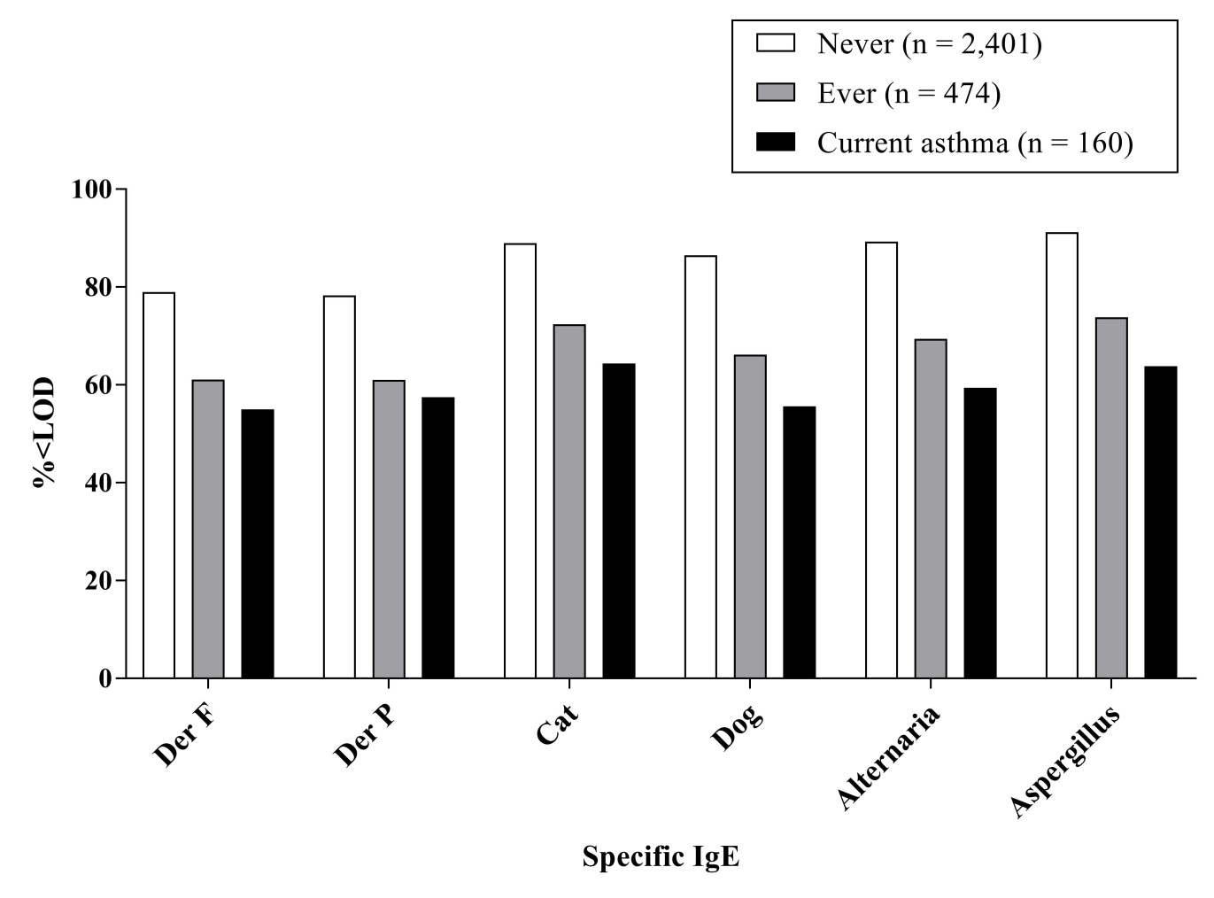
Supplementary Material 4. Percentage of under detection limit (%<LOD) of sIgE levels among the three groups
Der F, Dermatophagoides farina; Der P, Dermatophagoides pteronyssinus; sIgE, specific immunoglobulin E.

