Supplementary Material 1. Follow-up rate of the KEEP-II participants from 2012 to 2014 in Seoul and Asan

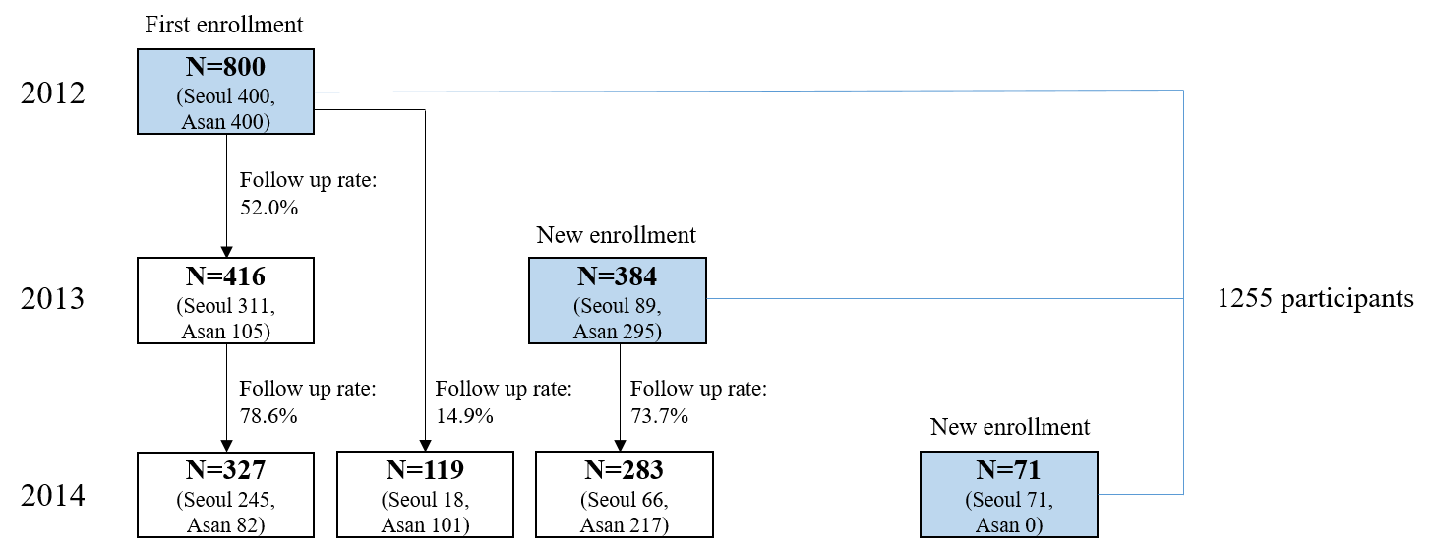

Supplementary Material 2.

Definition of covariates
1) Education level
(a) <middle school graduation, including “never been to school,” “elementary school dropout,” and “elementary school graduation/currently on middle school/middle school dropout”; (b) middle school graduation to two-year college, including “middle school graduation/currently on high school/high school dropout,” “high school graduation,” and “two-year college graduation”; (c) ≥four-year university dropout, including “four-year university dropout,” “currently on four-year university/graduation,” and “postgraduate and above.”

2) Physical activities
The frequency and duration of light, moderate, and severe physical activities were coded as 1.5 MET minutes, 4.5 MET minutes, and 8 MET minutes, respectively. The product of the frequency, duration (min), and intensity of exercise performed per week provided the total MET minutes per week.

Supplementary Material 3. Further adjustment with weekly vegetable(fruit) intake for weekly fruit(vegetable) intake in multiple covariate-adjusted models*
Cross-sectional multiple linear regression models (N=1,226)
Weekly fruit intake |  | β | (95% CI) | p-value |  | OR | (95% CI) | p-value
 | Never | 0 |  |  |  | 1
 | less than 1 time | –0.11 | (–0.23, 0.01) | 0.074 |  | 0.57 | (0.31, 1.07) | 0.080
 | 1-3 times | –0.17 | (–0.27, –0.06) | 0.002 |  | 0.69 | (0.41, 1.16) | 0.156
 | 4-6 times | –0.37 | (–0.51, –0.24) | <0.001 |  | 0.32 | (0.16, 0.64) | 0.001
 | Everyday | –0.35 | (–0.46, –0.23) | <0.001 |  | 0.43 | (0.24, 0.77) | 0.005
Weekly vegetable intake |  | β | (95% CI) | p-value |  | OR | (95% CI) | p-value
 | Never | 0 |  |  |  | 1
 | less than 1 time | –0.81 | (–1.14, –0.50) | <0.001 |  | 0.28 | (0.05, 1.47) | 0.133
 | 1-3 times | –0.12 | (–0.29, 0.06) | 0.197 |  | 0.72 | (0.29, 1.76) | 0.469
 | 4-6 times | –0.24 | (–0.43, –0.05) | 0.011 |  | 0.86 | (0.34, 2.17) | 0.752
 | Everyday | –0.05 | (–0.20, 0.11) | 0.550 |  | 0.93 | (0.42, 2.05) | 0.860
Generalized linear mixed-effect models (N=305 (915 observations))
Weekly fruit intake |  | β | (95% CI) | p-value |  | OR | (95% CI) | p-value
 | Never | 0 |  |  |  | 1
 | less than 1 time | 0.09 | (–0.09, 0.26) | 0.333 |  | 1.15 | (0.41, 3.27) | 0.792
 | 1-3 times | –0.08 | (–0.24, 0.07) | 0.283 |  | 0.51 | (0.20, 1.27) | 0.148
 | 4-6 times | –0.13 | (–0.32, 0.06) | 0.185 |  | 0.45 | (0.15, 1.35) | 0.153
 | Everyday | –0.11 | (–0.29, 0.06) | 0.201 |  | 0.31 | (0.12, 0.82) | 0.018
Weekly vegetable intake |  | β | (95% CI) | p-value |  | OR | (95% CI) | p-value
 | Never | 0 |  |  |  | 1
 | less than 1 time | 0.09 | (–0.33, 0.51) | 0.668 |  | 1.87 | (0.16, 21.84) | 0.617
 | 1-3 times | –0.01 | (–0.38, 0.36) | 0.974 |  | 1.30 | (0.15, 11.64) | 0.812
 | 4-6 times | –0.18 | (–0.56, 0.21) | 0.365 |  | 0.90 | (0.09, 8.85) | 0.928
 | Everyday | 0.07 | (–0.27, 0.42) | 0.679 |  | 2.15 | (0.28, 16.68) | 0.463
* Adjusted for age, sex, education, allowance (10,000KRW/month), smoking status, alcohol consumption status, household type, disease status, physical activity (MET minutes per week) and body mass index
Supplementary Material 4. The dose-dependent relationship between the weekly fruit/vegetable intake and SGDS-K (β) and depression status (OR) regarding Supplementary Material 3.
Cross-sectional multiple linear regression model (multiple covariate-adjusted) (N=1,226)
 |  | β (95% CI) | p-value | OR (95% CI) | p-value
Weekly fruit intake |  | –0.05 (–0.06, –0.03) | <0.001 | 0.90 (0.84, 0.96) | 0.000
Weekly vegetable intake |  | 0.02 (0.00, 0.04) | 0.011 | 1.04 (0.96, 1.12) | 0.337
Generalized linear mixed-effect model (multiple covariate-adjusted) (N=305 (915 observations))
 |  | β (95% CI) | p-value | OR (95% CI) | p-value
Weekly fruit intake |  | –0.05 (–0.06, 0.03) | <0.001 | 0.84 (0.75, 0.93) | 0.001
Weekly vegetable intake |  | 0.01 (–0.00, 0.03) | 0.149 | 1.10 (0.96, 1.26) | 0.153

* Covariates used for multiple covariate-adjusted model: age, sex, education, allowance (10,000KRW/month), smoking status, alcohol consumption status, household type, disease status, physical activity (MET minutes per week) and body mass index
† “never” is included in “less than 1 time”

Supplementary Material 5. Multiple covariate-adjusted models* after combining "never" and "less than 1 time" in weekly fruit/vegetable intake
Cross-sectional multiple linear regression models (N=1,226)
Weekly fruit intake |  | β | (95% CI) | p-value |  | OR | (95% CI) | p-value
 | less than 1 time† | 0 |  |  |  | 1
 | 1-3 times | –0.08 | (–0.16, 0.00) | 0.056 |  | 0.92 | (0.61, 1.40) | 0.707
 | 4-6 times | –0.33 | (–0.44, –0.22) | <0.001 |  | 0.44 | (0.24, 0.79) | 0.007
 | Everyday | –0.24 | (–0.34, –0.14) | <0.001 |  | 0.60 | (0.37, 0.98) | 0.043
Weekly vegetable intake |  | β | (95% CI) | p-value |  | OR | (95% CI) | p-value
 | less than 1 time | 0 |  |  |  | 1
 | 1-3 times | 0.06 | (–0.09, 0.22) | 0.427 |  | 0.96 | (0.44, 2.11) | 0.927
 | 4-6 times | –0.11 | (–0.28, 0.05) | 0.181 |  | 0.91 | (0.41, 2.05) | 0.829
 | Everyday | 0.09 | (–0.04, 0.23) | 0.177 |  | 1.08 | (0.56, 2.09) | 0.818
Generalized linear mixed-effects models (N=305 (915 observations))
Weekly fruit intake |  | β | (95% CI) | p-value |  | OR | (95% CI) | p-value
 | less than 1 time | 0 |  |  |  | 1
 | 1-3 times | –0.13 | (–0.25, –0.01) | 0.035 |  | 0.47 | (0.22, 0.99) | 0.046
 | 4-6 times | –0.18 | (–0.34, –0.01) | 0.034 |  | 0.42 | (0.16, 1.08) | 0.072
 | Everyday | –0.15 | (–0.30, 0.00) | 0.051 |  | 0.32 | (0.15, 0.71) | 0.005
Weekly vegetable intake |  | β | (95% CI) | p-value |  | OR | (95% CI) | p-value
 | less than 1 time | 0 |  |  |  | 1
 | 1-3 times | –0.11 | (–0.33, 0.12) | 0.365 |  | 0.76 | (0.19, 3.09) | 0.703
 | 4-6 times | –0.25 | (–0.51, 0.01) | 0.060 |  | 0.66 | (0.13, 3.22) | 0.605
 | Everyday | –0.01 | (–0.21, 0.19) | 0.904 |  | 1.26 | (0.38, 4.23) | 0.705

Supplementary Material 6. The dose-dependent relationship between the weekly fruit/vegetable intake and SGDS-K (β) and depression status (OR) regarding Supplementary Material 5.
Cross-sectional multiple linear regression model (multiple covariate-adjusted) (N=1226)
 |  | β (95% CI) | p-value | OR (95% CI) | p-value
Weekly fruit intake |  | –0.25 (–0.36, –0.14) | <0.001 | 0.44 (0.24, 0.81) | 0.008
Weekly vegetable intake |  | –0.18 (–0.32, –0.03) | 0.016 | 0.90 (0.43, 1.85) | 0.766
Generalized linear mixed-effect model (multiple covariate-adjusted) (N=305 (915 observations))
 |  | β (95% CI) | p-value | OR (95% CI) | p-value
Weekly fruit intake |  | –0.04 (–0.06, –0.03) | <0.001 | 0.86 (0.78, 0.96) | 0.005
Weekly vegetable intake |  | 0.01 (–0.01, 0.02) | 0.559 | 1.07 (0.94, 1.22) | 0.281

